Chapter 06
Discounted Cash Flow Valuation

Multiple Choice Questions
1. An ordinary annuity is best defined by which one of the following?
A. increasing payments paid for a definitive period of time
B. increasing payments paid forever
C. equal payments paid at regular intervals over a stated time period
D. equal payments paid at regular intervals of time on an ongoing basis
E. unequal payments that occur at set intervals for a limited period of time

2. Which one of the following accurately defines a perpetuity?
A. a limited number of equal payments paid in even time increments
B. payments of equal amounts that are paid irregularly but indefinitely
C. varying amounts that are paid at even intervals forever
D. unending equal payments paid at equal time intervals
E. unending equal payments paid at either equal or unequal time intervals

3. Which one of the following terms is used to identify a British perpetuity?
A. ordinary annuity
B. amortized cash flow
C. annuity due
D. discounted loan
E. consol

4. The interest rate that is quoted by a lender is referred to as which one of the following?
A. stated interest rate
B. compound rate
C. effective annual rate
D. simple rate
E. common rate

5. A monthly interest rate expressed as an annual rate would be an example of which one of the following rates?
A. stated rate
B. discounted annual rate
C. effective annual rate
D. periodic monthly rate
E. consolidated monthly rate

6. What is the interest rate charged per period multiplied by the number of periods per year called?
A. effective annual rate
B. annual percentage rate
C. periodic interest rate
D. compound interest rate
E. daily interest rate

7. A loan where the borrower receives money today and repays a single lump sum on a future date is called a(n) _____ loan.
A. amortized
B. continuous
C. balloon
D. pure discount
E. interest-only

8. Which one of the following terms is used to describe a loan that calls for periodic interest payments and a lump sum principal payment?
A. amortized loan
B. modified loan
C. balloon loan
D. pure discount loan
E. interest-only loan

9. Which one of the following terms is used to describe a loan wherein each payment is equal in amount and includes both interest and principal?
A. amortized loan
B. modified loan
C. balloon loan
D. pure discount loan
E. interest-only loan

10. Which one of the following terms is defined as a loan wherein the regular payments, including both interest and principal amounts, are insufficient to retire the entire loan amount, which then must be repaid in one lump sum?
A. amortized loan
B. continuing loan
C. balloon loan
D. remainder loan
E. interest-only loan

11. You are comparing two annuities which offer quarterly payments of $2,500 for five years and pay 0.75 percent interest per month. Annuity A will pay you on the first of each month while annuity B will pay you on the last day of each month. Which one of the following statements is correct concerning these two annuities?
A. These two annuities have equal present values but unequal futures values at the end of year five.
B. These two annuities have equal present values as of today and equal future values at the end of year five.
C. Annuity B is an annuity due.
D. Annuity A has a smaller future value than annuity B.
E. Annuity B has a smaller present value than annuity A.

12. You are comparing two investment options that each pay 5 percent interest, compounded annually. Both options will provide you with $12,000 of income. Option A pays three annual payments starting with $2,000 the first year followed by two annual payments of $5,000 each. Option B pays three annual payments of $4,000 each. Which one of the following statements is correct given these two investment options?
A. Both options are of equal value given that they both provide $12,000 of income.
B. Option A has the higher future value at the end of year three.
C. Option B has a higher present value at time zero than does option A.
D. Option B is a perpetuity.
E. Option A is an annuity.

13. You are considering two projects with the following cash flows:
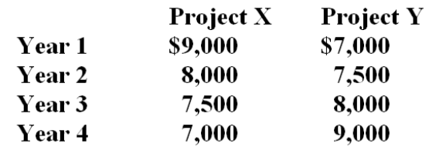
Which of the following statements are true concerning these two projects?
I. Both projects have the same future value at the end of year 4, given a positive rate of return.
II. Both projects have the same future value given a zero rate of return.
III. Project X has a higher present value than Project Y, given a positive discount rate.
IV. Project Y has a higher present value than Project X, given a positive discount rate.
A. II only
B. I and III only
C. II and III only
D. II and IV only
E. I, II, and IV only

14. Which one of the following statements is correct given the following two sets of project cash flows?
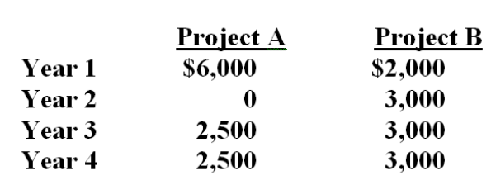
A. The cash flows for Project B are an annuity, but those of Project A are not.
B. Both sets of cash flows have equal present values as of time zero given a positive discount rate.
C. The present value at time zero of the final cash flow for Project A will be discounted using an exponent of three.
D. The present value of Project A cannot be computed because the second cash flow is equal to zero.
E. As long as the discount rate is positive, Project B will always be worth less today than will Project A.

15. Which one of the following statements related to annuities and perpetuities is correct?
A. An ordinary annuity is worth more than an annuity due given equal annual cash flows for ten years at 7 percent interest, compounded annually.
B. A perpetuity comprised of $100 monthly payments is worth more than an annuity comprised of $100 monthly payments, given an interest rate of 12 percent, compounded monthly.
C. Most loans are a form of a perpetuity.
D. The present value of a perpetuity cannot be computed, but the future value can.
E. Perpetuities are finite but annuities are not.

16. Which of the following statements related to interest rates are correct?
I. Annual interest rates consider the effect of interest earned on reinvested interest payments.
II. When comparing loans, you should compare the effective annual rates.
III. Lenders are required by law to disclose the effective annual rate of a loan to prospective borrowers.
IV. Annual and effective interest rates are equal when interest is compounded annually.
A. I and II only
B. II and III only
C. II and IV only
D. I, II, and III only
E. II, III, and IV only

17. Which one of the following statements concerning interest rates is correct?
A. Savers would prefer annual compounding over monthly compounding.
B. The effective annual rate decreases as the number of compounding periods per year increases.
C. The effective annual rate equals the annual percentage rate when interest is compounded annually.
D. Borrowers would prefer monthly compounding over annual compounding.
E. For any positive rate of interest, the effective annual rate will always exceed the annual percentage rate.

18. Which one of these statements related to growing annuities and perpetuities is correct?
A. The cash flow used in the growing annuity formula is the initial cash flow at time zero.
B. Growth rates cannot be applied to perpetuities if you wish to compute the present value.
C. The future value of an annuity will decrease if the growth rate is increased.
D. An increase in the rate of growth will decrease the present value of an annuity.
E. The present value of a growing perpetuity will decrease if the discount rate is increased.

19. Which one of the following statements correctly states a relationship?
A. Time and future values are inversely related, all else held constant.
B. Interest rates and time are positively related, all else held constant.
C. An increase in the discount rate increases the present value, given positive rates.
D. An increase in time increases the future value given a zero rate of interest.
E. Time and present value are inversely related, all else held constant.

20. Which one of the following compounding periods will yield the smallest present value given a stated future value and annual percentage rate?
A. annual
B. semi-annual
C. monthly
D. daily
E. continuous

21. The entire repayment of which one of the following loans is computed simply by computing a single future value?
A. interest-only loan
B. balloon loan
C. amortized loan
D. pure discount loan
E. bullet loan

22. How is the principal amount of an interest-only loan repaid?
A. The principal is forgiven over the loan period so does not have to be repaid.
B. The principal is repaid in equal increments and included in each loan payment.
C. The principal is repaid in a lump sum at the end of the loan period.
D. The principal is repaid in equal annual payments.
E. The principal is repaid in increasing increments through regular monthly payments.

23. An amortized loan:
A. requires the principal amount to be repaid in even increments over the life of the loan.
B. may have equal or increasing amounts applied to the principal from each loan payment.
C. requires that all interest be repaid on a monthly basis while the principal is repaid at the end of the loan term.
D. requires that all payments be equal in amount and include both principal and interest.
E. repays both the principal and the interest in one lump sum at the end of the loan term.

24. You need $25,000 today and have decided to take out a loan at 7 percent for five years. Which one of the following loans would be the least expensive? Assume all loans require monthly payments and that interest is compounded on a monthly basis.
A. interest-only loan
B. amortized loan with equal principal payments
C. amortized loan with equal loan payments
D. discount loan
E. balloon loan where 50 percent of the principal is repaid as a balloon payment

25. Your grandmother is gifting you $100 a month for four years while you attend college to earn your bachelor's degree. At a 5.5 percent discount rate, what are these payments worth to you on the day you enter college?
A. $4,201.16
B. $4,299.88
C. $4,509.19
D. $4,608.87
E. $4,800.00

26. You just won the grand prize in a national writing contest! As your prize, you will receive $2,000 a month for ten years. If you can earn 7 percent on your money, what is this prize worth to you today?
A. $172,252.71
B. $178,411.06
C. $181,338.40
D. $185,333.33
E. $190,450.25

27. Phil can afford $180 a month for 5 years for a car loan. If the interest rate is 8.6 percent, how much can he afford to borrow to purchase a car?
A. $7,750.00
B. $8,348.03
C. $8,752.84
D. $9,266.67
E. $9,400.00

28. You are the beneficiary of a life insurance policy. The insurance company informs you that you have two options for receiving the insurance proceeds. You can receive a lump sum of $200,000 today or receive payments of $1,400 a month for 20 years. You can earn 6 percent on your money. Which option should you take and why?
A. You should accept the payments because they are worth $209,414 to you today.
B. You should accept the payments because they are worth $247,800 to you today.
C. You should accept the payments because they are worth $336,000 to you today.
D. You should accept the $200,000 because the payments are only worth $189,311 to you today.
E. You should accept the $200,000 because the payments are only worth $195,413 to you today.

29. Your employer contributes $75 a week to your retirement plan. Assume that you work for your employer for another 20 years and that the applicable discount rate is 7.5 percent. Given these assumptions, what is this employee benefit worth to you today?
A. $40,384.69
B. $42,618.46
C. $44,211.11
D. $44,306.16
E. $44,987.74

30. The Design Team just decided to save $1,500 a month for the next 5 years as a safety net for recessionary periods. The money will be set aside in a separate savings account which pays 4.5 percent interest compounded monthly. The first deposit will be made today. What would today's deposit amount have to be if the firm opted for one lump sum deposit today that would yield the same amount of savings as the monthly deposits after 5 years?
A. $80,459.07
B. $80,760.79
C. $81,068.18
D. $81,333.33
E. $81,548.20

31. You need some money today and the only friend you have that has any is your miserly friend. He agrees to loan you the money you need, if you make payments of $25 a month for the next six months. In keeping with his reputation, he requires that the first payment be paid today. He also charges you 1.5 percent interest per month. How much money are you borrowing?
A. $134.09
B. $138.22
C. $139.50
D. $142.68
E. $144.57

32. You buy an annuity that will pay you $24,000 a year for 25 years. The payments are paid on the first day of each year. What is the value of this annuity today if the discount rate is 8.5 percent?
A. $241,309
B. $245,621
C. $251,409
D. $258,319
E. $266,498

33. You are scheduled to receive annual payments of $4,800 for each of the next 7 years. The discount rate is 8 percent. What is the difference in the present value if you receive these payments at the beginning of each year rather than at the end of each year?
A. $1,999
B. $2,013
C. $2,221
D. $2,227
E. $2,304

34. You are comparing two annuities with equal present values. The applicable discount rate is 8.75 percent. One annuity pays $5,000 on the first day of each year for 20 years. How much does the second annuity pay each year for 20 years if it pays at the end of each year?
A. $5,211
B. $5,267
C. $5,309
D. $5,390
E. $5,438

35. Trish receives $480 on the first of each month. Josh receives $480 on the last day of each month. Both Trish and Josh will receive payments for next three years. At a 9.5 percent discount rate, what is the difference in the present value of these two sets of payments?
A. $118.63
B. $121.06
C. $124.30
D. $129.08
E. $132.50

36. What is the future value of $1,200 a year for 40 years at 8 percent interest? Assume annual compounding.
A. $301,115
B. $306,492
C. $310,868
D. $342,908
E. $347,267

37. What is the future value of $15,000 a year for 30 years at 12 percent interest?
A. $2,878,406
B. $3,619,990
C. $3,711,414
D. $3,989,476
E. $4,021,223

38. Alexa plans on saving $3,000 a year and expects to earn an annual rate of 10.25 percent. How much will she have in her account at the end of 45 years?
A. $1,806,429
B. $1,838,369
C. $2,211,407
D. $2,333,572
E. $2,508,316

39. Theresa adds $1,000 to her savings account on the first day of each year. Marcus adds $1,000 to his savings account on the last day of each year. They both earn 6.5 percent annual interest. What is the difference in their savings account balances at the end of 35 years?
A. $8,062
B. $8,113
C. $8,127
D. $8,211
E. $8,219

40. You are borrowing $17,800 to buy a car. The terms of the loan call for monthly payments for 5 years at 8.6 percent interest. What is the amount of each payment?
A. $287.71
B. $291.40
C. $301.12
D. $342.76
E. $366.05

41. You borrow $165,000 to buy a house. The mortgage rate is 7.5 percent and the loan period is 30 years. Payments are made monthly. If you pay the mortgage according to the loan agreement, how much total interest will you pay?
A. $206,408
B. $229,079
C. $250,332
D. $264,319
E. $291,406

42. Holiday Tours (HT) has an employment contract with its newly hired CEO. The contract requires a lump sum payment of $10.4 million be paid to the CEO upon the successful completion of her first three years of service. HT wants to set aside an equal amount of money at the end of each year to cover this anticipated cash outflow and will earn 5.65 percent on the funds. How much must HT set aside each year for this purpose?
A. $3,184,467
B. $3,277,973
C. $3,006,409
D. $3,318,190
E. $3,466,667

43. Nadine is retiring at age 62 and expects to live to age 85. On the day she retires, she has $348,219 in her retirement savings account. She is somewhat conservative with her money and expects to earn 6 percent during her retirement years. How much can she withdraw from her retirement savings each month if she plans to spend her last penny on the morning of her death?
A. $1,609.92
B. $1,847.78
C. $1,919.46
D. $2,116.08
E. $2,329.05

44. Kingston Development Corp. purchased a piece of property for $2.79 million. The firm paid a down payment of 15 percent in cash and financed the balance. The loan terms require monthly payments for 15 years at an annual percentage rate of 7.75 percent, compounded monthly. What is the amount of each mortgage payment?
A. $22,322.35
B. $23,419.97
C. $23,607.11
D. $24,878.15
E. $25,301.16

45. You estimate that you will owe $42,800 in student loans by the time you graduate. The interest rate is 4.25 percent. If you want to have this debt paid in full within six years, how much must you pay each month?
A. $611.09
B. $674.50
C. $714.28
D. $736.05
E. $742.50

46. You are buying a previously owned car today at a price of $3,500. You are paying $300 down in cash and financing the balance for 36 months at 8.5 percent. What is the amount of each loan payment?
A. $101.02
B. $112.23
C. $118.47
D. $121.60
E. $124.40

47. Atlas Insurance wants to sell you an annuity which will pay you $3,400 per quarter for 25 years. You want to earn a minimum rate of return of 6.5 percent. What is the most you are willing to pay as a lump sum today to buy this annuity?
A. $151,008.24
B. $154,208.16
C. $167,489.11
D. $173,008.80
E. $178,927.59

48. Your car dealer is willing to lease you a new car for $245 a month for 48 months. Payments are due on the first day of each month starting with the day you sign the lease contract. If your cost of money is 6.5 percent, what is the current value of the lease?
A. $10,331.03
B. $10,386.99
C. $12,197.74
D. $12,203.14
E. $13,008.31

49. Your great aunt left you an inheritance in the form of a trust. The trust agreement states that you are to receive $3,600 on the first day of each year, starting immediately and continuing for 20 years. What is the value of this inheritance today if the applicable discount rate is 6.75 percent?
A. $38,890.88
B. $40,311.16
C. $41,516.01
D. $42,909.29
E. $43,333.33

50. You just received an insurance settlement offer related to an accident you had six years ago. The offer gives you a choice of one of the following three offers:
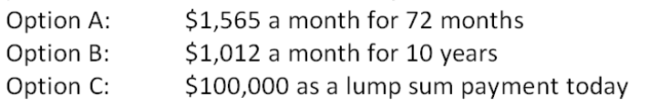
You can earn 7.5 percent on your investments. You do not care if you personally receive the funds or if they are paid to your heirs should you die within the settlement period. Which one of the following statements is correct given this information?
A. Option A is the best choice as it provides the largest monthly payment.
B. Option B is the best choice because it pays the largest total amount.
C. Option C is the best choice because it is has the largest current value.
D. Option B is the best choice because you will receive the most payments.
E. You are indifferent to the three options as they are all equal in value.

51. Samuelson Engines wants to save $750,000 to buy some new equipment six years from now. The plan is to set aside an equal amount of money on the first day of each quarter starting today. The firm can earn 4.75 percent on its savings. How much does the firm have to save each quarter to achieve its goal?
A. $26,872.94
B. $26,969.70
C. $27,192.05
D. $27,419.29
E. $27,911.08

52. Stephanie is going to contribute $300 on the first of each month, starting today, to her retirement account. Her employer will provide a 50 percent match. In other words, her employer will contribute 50 percent of the amount Stephanie saves. If both Stephanie and her employer continue to do this and she can earn a monthly rate of 0.90 percent, how much will she have in her retirement account 35 years from now?
A. $1,936,264
B. $1,943,286
C. $1,989,312
D. $2,068,418
E. $2,123,007

53. You are considering an annuity which costs $160,000 today. The annuity pays $18,126 a year at an annual interest rate of 7.50 percent. What is the length of the annuity time period?
A. 12 years
B. 13 years
C. 14 years
D. 15 years
E. 16 years

54. Today, you borrowed $6,200 on your credit card to purchase some furniture. The interest rate is 14.9 percent, compounded monthly. How long will it take you to pay off this debt assuming that you do not charge anything else and make regular monthly payments of $120?
A. 5.87 years
B. 6.40 years
C. 6.93 years
D. 7.23 years
E. 7.31 years

55. Meadow Brook Manor would like to buy some additional land and build a new assisted living center. The anticipated total cost is $23.6 million. The CEO of the firm is quite conservative and will only do this when the company has sufficient funds to pay cash for the entire construction project. Management has decided to save $1.2 million a quarter for this purpose. The firm earns 6.25 percent, compounded quarterly, on the funds it saves. How long does the company have to wait before expanding its operations?
A. 4.09 years
B. 4.32 years
C. 4.46 years
D. 4.82 years
E. 4.91 years

56. Today, you are retiring. You have a total of $411,016 in your retirement savings and have the funds invested such that you expect to earn an average of 7.10 percent, compounded monthly, on this money throughout your retirement years. You want to withdraw $2,500 at the beginning of every month, starting today. How long will it be until you run out of money?
A. 31.97 years
B. 34.56 years
C. 42.03 year
D. 48.19 years
E. You will never run out of money.

57. Gene's Art Gallery is notoriously known as a slow-payer. The firm currently needs to borrow $27,500 and only one company will even deal with them. The terms of the loan call for daily payments of $100. The first payment is due today. The interest rate is 21.9 percent, compounded daily. What is the time period of this loan? Assume a 365 day year.
A. 264.36 days
B. 280.81 days
C. 300.43 days
D. 316.46 days
E. 341.09 days

58. The Wine Press is considering a project which has an initial cash requirement of $187,400. The project will yield cash flows of $2,832 monthly for 84 months. What is the rate of return on this project?
A. 6.97 percent
B. 7.04 percent
C. 7.28 percent
D. 7.41 percent
E. 7.56 percent

59. Your insurance agent is trying to sell you an annuity that costs $200,000 today. By buying this annuity, your agent promises that you will receive payments of $1,225 a month for the next 30 years. What is the rate of return on this investment?
A. 5.75 percent
B. 5.97 percent
C. 6.20 percent
D. 6.45 percent
E. 6.67 percent

60. You have been investing $250 a month for the last 13 years. Today, your investment account is worth $73,262. What is your average rate of return on your investments?
A. 8.94 percent
B. 9.23 percent
C. 9.36 percent
D. 9.41 percent
E. 9.78 percent

61. Will has been purchasing $25,000 worth of New Tek stock annually for the past 11 years. His holdings are now worth $598,100. What is his annual rate of return on this stock?
A. 14.13 percent
B. 14.24 percent
C. 14.29 percent
D. 14.37 percent
E. 14.68 percent

62. Your father helped you start saving $20 a month beginning on your 5th birthday. He always made you deposit the money into your savings account on the first day of each month just to "start the month out right." Today completes your 17th year of saving and you now have $6,528.91 in this account. What is the rate of return on your savings?
A. 5.15 percent
B. 5.30 percent
C. 5.47 percent
D. 5.98 percent
E. 6.12 percent

63. Today, you turn 23. Your birthday wish is that you will be a millionaire by your 40th birthday. In an attempt to reach this goal, you decide to save $50 a day, every day until you turn 40. You open an investment account and deposit your first $50 today. What rate of return must you earn to achieve your goal?
A. 10.67 percent
B. 11.85 percent
C. 12.90 percent
D. 13.06 percent
E. 13.54 percent

64. You just settled an insurance claim. The settlement calls for increasing payments over a 10-year period. The first payment will be paid one year from now in the amount of $10,000. The following payments will increase by 4.5 percent annually. What is the value of this settlement to you today if you can earn 8 percent on your investments?
A. $76,408.28
B. $80,192.76
C. $82,023.05
D. $84,141.14
E. $85,008.16

65. Your grandfather left you an inheritance that will provide an annual income for the next 10 years. You will receive the first payment one year from now in the amount of $4,000. Every year after that, the payment amount will increase by 6 percent. What is your inheritance worth to you today if you can earn 9.5 percent on your investments?
A. $31,699.15
B. $36,666.67
C. $41,121.21
D. $43,464.12
E. $46,908.17

66. You just won a national sweepstakes! For your prize, you opted to receive never-ending payments. The first payment will be $12,500 and will be paid one year from today. Every year thereafter, the payments will increase by 3.5 percent annually. What is the present value of your prize at a discount rate of 8 percent?
A. $166,666.67
B. $248,409.19
C. $277,777.78
D. $291,006.12
E. $300,000.00

67. A wealthy benefactor just donated some money to the local college. This gift was established to provide scholarships for worthy students. The first scholarships will be granted one year from now for a total of $35,000. Annually thereafter, the scholarship amount will be increased by 5.5 percent to help offset the effects of inflation. The scholarship fund will last indefinitely. What is the value of this gift today at a discount rate of 8 percent?
A. $437,500
B. $750,000
C. $1,200,000
D. $1,400,000
E. $1,450,750

68. Southern Tours is considering acquiring Holiday Vacations. Management believes Holiday Vacations can generate cash flows of $187,000, $220,000, and $245,000 over the next three years, respectively. After that time, they feel the business will be worthless. Southern Tours has determined that a 13.5 percent rate of return is applicable to this potential acquisition. What is Southern Tours willing to pay today to acquire Holiday Vacations?
A. $503,098
B. $538,615
C. $545,920
D. $601,226
E. $638,407

69. You are considering two savings options. Both options offer a 7.4 percent rate of return. The first option is to save $900, $2,100, and $3,000 at the end of each year for the next three years, respectively. The other option is to save one lump sum amount today. If you want to have the same balance in your savings account at the end of the three years, regardless of the savings method you select, how much do you need to save today if you select the lump sum option?
A. $4,410
B. $4,530
C. $4,600
D. $5,080
E. $5,260

70. Your parents have made you two offers. The first offer includes annual gifts of $10,000, $11,000, and $12,000 at the end of each of the next three years, respectively. The other offer is the payment of one lump sum amount today. You are trying to decide which offer to accept given the fact that your discount rate is 8 percent. What is the minimum amount that you will accept today if you are to select the lump sum offer?
A. $28,216
B. $29,407
C. $29,367
D. $30,439
E. $30,691

71. You are considering changing jobs. Your goal is to work for three years and then return to school full-time in pursuit of an advanced degree. A potential employer just offered you an annual salary of $41,000, $44,000, and $46,000 a year for the next three years, respectively. All salary payments are made as lump sum payments at the end of each year. The offer also includes a starting bonus of $2,500 payable immediately. What is this offer worth to you today at a discount rate of 6.75 percent?
A. $112,406
B. $115,545
C. $117,333
D. $121,212
E. $134,697

72. You are considering a project which will provide annual cash inflows of $4,500, $5,700, and $8,000 at the end of each year for the next three years, respectively. What is the present value of these cash flows, given a 9 percent discount rate?
A. $14,877
B. $15,103
C. $15,429
D. $16,388
E. $16,847

73. You just signed a consulting contract that will pay you $35,000, $52,000, and $80,000 annually at the end of the next three years, respectively. What is the present value of these cash flows given a 10.5 percent discount rate?
A. $133,554
B. $142,307
C. $148,880
D. $151,131
E. $156,910

74. You have some property for sale and have received two offers. The first offer is for $89,500 today in cash. The second offer is the payment of $35,000 today and an additional $70,000 two years from today. If the applicable discount rate is 11.5 percent, which offer should you accept and why?
A. You should accept the $89,500 today because it has the higher net present value.
B. You should accept the $89,500 today because it has the lower future value.
C. You should accept the first offer as it has the greatest value to you.
D. You should accept the second offer because it has the larger net present value.
E. It does not matter which offer you accept as they are equally valuable.

75. Your local travel agent is advertising an upscale winter vacation package for travel three years from now to Antarctica. The package requires that you pay $25,000 today, $30,000 one year from today, and a final payment of $45,000 on the day you depart three years from today. What is the cost of this vacation in today's dollars if the discount rate is 9.75 percent?
A. $86,376
B. $89,695
C. $91,219
D. $91,407
E. $93,478

76. One year ago, Deltona Motor Parts deposited $16,500 in an investment account for the purpose of buying new equipment three years from today. Today, it is adding another $12,000 to this account. The company plans on making a final deposit of $20,000 to the account one year from today. How much will be available when it is ready to buy the equipment, assuming the account pays 5.5 interest?
A. $53,408
B. $53,919
C. $56,211
D. $56,792
E. $58,021

77. Lucas will receive $6,800, $8,700, and $12,500 each year starting at the end of year one. What is the future value of these cash flows at the end of year five if the interest rate is 7 percent?
A. $32,418
B. $32,907
C. $33,883
D. $35,411
E. $36,255

78. You plan on saving $5,200 this year, nothing next year, and $7,500 the following year. You will deposit these amounts into your investment account at the end of each year. What will your investment account be worth at the end of year three if you can earn 8.5 percent on your funds?
A. $13,528.12
B. $13,621.57
C. $13,907.11
D. $14,526.50
E. $14,779.40

79. Miley expects to receive the following payments: Year 1 = $60,000; Year 2 = $35,000; Year 3 = $12,000. All of this money will be saved for her retirement. If she can earn an average of 10.5 percent on her investments, how much will she have in her account 25 years after making her first deposit?
A. $972,373
B. $989,457
C. $1,006,311
D. $1,147,509
E. $1,231,776

80. Blackwell, Inc. has a $75,000 liability it must pay three years from today. The company is opening a savings account so that the entire amount will be available when this debt needs to be paid. The plan is to make an initial deposit today and then deposit an additional $15,000 each year for the next three years, starting one year from today. The account pays a 4.5 percent rate of return. How much does the firm need to deposit today?
A. $18,299.95
B. $20,072.91
C. $21,400.33
D. $24,487.78
E. $31,076.56

81. The government has imposed a fine on the Corner Tavern. The fine calls for annual payments of $150,000, $100,000, $75,000, and $50,000, respectively, over the next four years. The first payment is due one year from today. The government plans to invest the funds until the final payment is collected and then donate the entire amount, including the investment earnings, to help the local community shelter. The government will earn 6.25 percent on the funds held. How much will the community shelter receive four years from today?
A. $349,674.06
B. $366,875.00
C. $422,497.56
D. $458,572.71
E. $515,737.67

82. Wicker Imports established a trust fund that provides $90,000 in scholarships each year for needy students. The trust fund earns a fixed 6 percent rate of return. How much money did the firm contribute to the fund assuming that only the interest income is distributed?
A. $1,150,000
B. $1,200,000
C. $1,333,333
D. $1,500,000
E. $1,600,000

83. A preferred stock pays an annual dividend of $2.60. What is one share of this stock worth today if the rate of return is 11.75 percent?
A. $18.48
B. $20.00
C. $22.13
D. $28.80
E. $30.55

84. You would like to establish a trust fund that will provide $120,000 a year forever for your heirs. The trust fund is going to be invested very conservatively so the expected rate of return is only 5.75 percent. How much money must you deposit today to fund this gift for your heirs?
A. $2,086,957
B. $2,121,212
C. $2,300,000
D. $2,458,122
E. $2,500,000

85. You just paid $750,000 for an annuity that will pay you and your heirs $45,000 a year forever. What rate of return are you earning on this policy?
A. 5.25 percent
B. 5.50 percent
C. 5.75 percent
D. 6.00 percent
E. 6.25 percent

86. You grandfather won a lottery years ago. The value of his winnings at the time was $50,000. He invested this money such that it will provide annual payments of $2,400 a year to his heirs forever. What is the rate of return?
A. 4.75 percent
B. 4.80 percent
C. 5.00 percent
D. 5.10 percent
E. 5.15 percent

87. The preferred stock of Casco has a 5.48 percent dividend yield. The stock is currently priced at $59.30 per share. What is the amount of the annual dividend?
A. $2.80
B. $2.95
C. $3.10
D. $3.25
E. $3.40

88. Your credit card company charges you 1.65 percent interest per month. What is the annual percentage rate on your account?
A. 18.95 percent
B. 19.80 percent
C. 20.90 percent
D. 21.25 percent
E. 21.70 percent

89. What is the annual percentage rate on a loan with a stated rate of 2.25 percent per quarter?
A. 9.00 percent
B. 9.09 percent
C. 9.18 percent
D. 9.27 percent
E. 9.31 percent

90. You are paying an effective annual rate of 18.974 percent on your credit card. The interest is compounded monthly. What is the annual percentage rate on this account?
A. 17.50 percent
B. 18.00 percent
C. 18.25 percent
D. 18.64 percent
E. 19.00 percent

91. What is the effective annual rate if a bank charges you 9.50 percent compounded quarterly?
A. 9.62 percent
B. 9.68 percent
C. 9.72 percent
D. 9.84 percent
E. 9.91 percent

92. Your credit card company quotes you a rate of 17.9 percent. Interest is billed monthly. What is the actual rate of interest you are paying?
A. 19.03 percent
B. 19.21 percent
C. 19.44 percent
D. 19.57 percent
E. 19.72 percent

93. The Pawn Shop loans money at an annual rate of 21 percent and compounds interest weekly. What is the actual rate being charged on these loans?
A. 23.16 percent
B. 23.32 percent
C. 23.49 percent
D. 23.56 percent
E. 23.64 percent

94. You are considering two loans. The terms of the two loans are equivalent with the exception of the interest rates. Loan A offers a rate of 7.75 percent, compounded daily. Loan B offers a rate of 8 percent, compounded semi-annually. Which loan should you select and why?
A. A; the effective annual rate is 8.06 percent.
B. A; the annual percentage rate is 7.75 percent.
C. B; the annual percentage rate is 7.68 percent.
D. B; the effective annual rate is 8.16 percent.
E. The loans are equivalent offers so you can select either one.

95. You have $5,600 that you want to use to open a savings account. There are five banks located in your area. The rates paid by banks A through E, respectively, are given below. Which bank should you select if your goal is to maximize your interest income?
A. 3.26 percent, compounded annually
B. 3.20 percent, compounded monthly
C. 3.25 percent, compounded semi-annually
D. 3.10 percent, compounded continuously
E. 3.15 percent, compounded quarterly

96. What is the effective annual rate of 14.9 percent compounded continuously?
A. 15.59 percent
B. 15.62 percent
C. 15.69 percent
D. 15.84 percent
E. 16.07 percent

97. What is the effective annual rate of 9.75 percent compounded continuously?
A. 10.17 percent
B. 10.24 percent
C. 10.29 percent
D. 10.33 percent
E. 10.47 percent

98. City Bank wants to appear competitive based on quoted loan rates and thus must offer a 7.75 percent annual percentage rate on its loans. What is the maximum rate the bank can actually earn based on the quoted rate?
A. 8.06 percent
B. 8.14 percent
C. 8.21 percent
D. 8.26 percent
E. 8.58 percent

99. You are going to loan a friend $900 for one year at a 5 percent rate of interest, compounded annually. How much additional interest could you have earned if you had compounded the rate continuously rather than annually?
A. $0.97
B. $1.14
C. $1.23
D. $1.36
E. $1.41

100. You are borrowing money today at 8.48 percent, compounded annually. You will repay the principal plus all the interest in one lump sum of $12,800 two years from today. How much are you borrowing?
A. $9,900.00
B. $10,211.16
C. $10,877.04
D. $11,401.16
E. $11,250.00

101. This morning, you borrowed $9,500 at 7.65 percent annual interest. You are to repay the loan principal plus all of the loan interest in one lump sum four years from today. How much will you have to repay?
A. $12,757.92
B. $12,808.13
C. $12,911.89
D. $13,006.08
E. $13,441.20

102. On this date last year, you borrowed $3,400. You have to repay the loan principal plus all of the interest six years from today. The payment that is required at that time is $6,000. What is the interest rate on this loan?
A. 8.01 percent
B. 8.45 percent
C. 8.78 percent
D. 9.47 percent
E. 9.93 percent

103. John's Auto Repair just took out an $89,000, 10-year, 8 percent, interest-only loan from the bank. Payments are made annually. What is the amount of the loan payment in year 10?
A. $7,120
B. $8,850
C. $13,264
D. $89,000
E. $96,120

104. On the day you entered college, you borrowed $18,000 on an interest-only, four-year loan at 5.25 percent from your local bank. Payments are to be paid annually. What is the amount of your loan payment in year 2?
A. $945
B. $1,890
C. $3,600
D. $5,106
E. $6,250

105. On the day you entered college you borrowed $25,000 from your local bank. The terms of the loan include an interest rate of 4.75 percent. The terms stipulate that the principal is due in full one year after you graduate. Interest is to be paid annually at the end of each year. Assume that you complete college in four years. How much total interest will you pay on this loan?
A. $5,266.67
B. $5,400.00
C. $5,937.50
D. $6,529.00
E. $6,607.11

106. You just acquired a mortgage in the amount of $249,500 at 6.75 percent interest, compounded monthly. Equal payments are to be made at the end of each month for thirty years. How much of the first loan payment is interest? (Assume each month is equal to 1/12 of a year.)
A. $925.20
B. $1,206.16
C. $1,403.44
D. $1,511.21
E. $1,548.60

107. On June 1, you borrowed $212,000 to buy a house. The mortgage rate is 8.25 percent. The loan is to be repaid in equal monthly payments over 15 years. The first payment is due on July 1. How much of the second payment applies to the principal balance? (Assume that each month is equal to 1/12 of a year.)
A. $603.32
B. $698.14
C. $1,358.56
D. $1,453.38
E. $2,056.70

108. This morning, you borrowed $150,000 to buy a house. The mortgage rate is 7.35 percent. The loan is to be repaid in equal monthly payments over 20 years. The first payment is due one month from today. How much of the second payment applies to the principal balance? (Assume that each month is equal to 1/12 of a year.)
A. $268.84
B. $277.61
C. $917.06
D. $925.83
E. $1,194.67

Essay Questions
109. Explain the difference between the effective annual rate (EAR) and the annual percentage rate (APR). Of the two, which one has the greater importance and why?

110. You are considering two annuities, both of which pay a total of $20,000 over the life of the annuity. Annuity A pays $2,000 at the end of each year for the next 10 years. Annuity B pays $1,000 at the end of each year for the next 20 years. Which annuity has the greater value today? Is there any circumstance where the two annuities would have equal values as of today? Explain.

111. Why might a borrower select an interest-only loan instead of an amortized loan, which would be cheaper?

112. Kristie owns a perpetuity which pays $12,000 at the end of each year. She comes to you and offers to sell you all of the payments to be received after the 10th year. Explain how you can determine the value of this offer.

Multiple Choice Questions
113. Western Bank offers you a $21,000, 6-year term loan at 8 percent annual interest. What is the amount of your annual loan payment?
A. $4,228.50
B. $4,542.62
C. $4,666.67
D. $4,901.18
E. $5,311.07

114. First Century Bank wants to earn an effective annual return on its consumer loans of 10 percent per year. The bank uses daily compounding on its loans. By law, what interest rate is the bank required to report to potential borrowers?
A. 9.23 percent
B. 9.38 percent
C. 9.53 percent
D. 9.72 percent
E. 10.00 percent

115. Downtown Bank is offering 3.4 percent compounded daily on its savings accounts. You deposit $8,000 today. How much will you have in your account 11 years from now?
A. $11,628.09
B. $11,714.06
C. $12,204.50
D. $12,336.81
E. $12,414.14

116. You want to buy a new sports coupe for $41,750, and the finance office at the dealership has quoted you an 8.6 percent APR loan compounded monthly for 48 months to buy the car. What is the effective interest rate on this loan?
A. 8.28 percent
B. 8.41 percent
C. 8.72 percent
D. 8.87 percent
E. 8.95 percent

117. Beginning three months from now, you want to be able to withdraw $1,500 each quarter from your bank account to cover college expenses over the next 4 years. The account pays 1.25 percent interest per quarter. How much do you need to have in your account today to meet your expense needs over the next 4 years?
A. $21,630.44
B. $21,847.15
C. $22,068.00
D. $22,454.09
E. $22,711.18

118. You are planning to save for retirement over the next 15 years. To do this, you will invest $1,100 a month in a stock account and $500 a month in a bond account. The return on the stock account is expected to be 7 percent, and the bond account will pay 4 percent. When you retire, you will combine your money into an account with a 5 percent return. How much can you withdraw each month during retirement assuming a 20-year withdrawal period?
A. $2,636.19
B. $2,904.11
C. $3,008.21
D. $3,113.04
E. $3,406.97

119. You want to be a millionaire when you retire in 40 years. You can earn an 11 percent annual return. How much more will you have to save each month if you wait 10 years to start saving versus if you start saving at the end of this month?
A. $79.22
B. $114.13
C. $168.47
D. $201.15
E. $240.29

120. You have just won the lottery and will receive $540,000 as your first payment one year from now. You will receive payments for 26 years. The payments will increase in value by 4 percent each year. The appropriate discount rate is 10 percent. What is the present value of your winnings?
A. $6,221,407
B. $6,906,372
C. $7,559,613
D. $7,811,406
E. $8,003.11

121. You are preparing to make monthly payments of $65, beginning at the end of this month, into an account that pays 6 percent interest compounded monthly. How many payments will you have made when your account balance reaches $9,278?
A. 97
B. 108
C. 119
D. 124
E. 131

122. You want to borrow $47,170 from your local bank to buy a new sailboat. You can afford to make monthly payments of $1,160, but no more. Assume monthly compounding. What is the highest rate you can afford on a 48-month APR loan?
A. 8.38 percent
B. 8.67 percent
C. 8.82 percent
D. 9.01 percent
E. 9.18 percent

123. You need a 25-year, fixed-rate mortgage to buy a new home for $240,000. Your mortgage bank will lend you the money at a 7.5 percent APR for this 300-month loan, with interest compounded monthly. However, you can only afford monthly payments of $850, so you offer to pay off any remaining loan balance at the end of the loan in the form of a single balloon payment. What will be the amount of the balloon payment if you are to keep your monthly payments at $850?
A. $738,464
B. $745,316
C. $767,480
D. $810,220
E. $847,315

124. The present value of the following cash flow stream is $5,933.86 when discounted at 11 percent annually. What is the value of the missing cash flow?
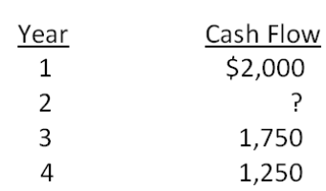
A. $1,500
B. $1,750
C. $2,000
D. $2,250
E. $2,500

125. You have just purchased a new warehouse. To finance the purchase, you've arranged for a 30-year mortgage loan for 80 percent of the $2,600,000 purchase price. The monthly payment on this loan will be $11,000. What is the effective annual rate on this loan?
A. 4.98 percent
B. 5.25 percent
C. 5.46 percent
D. 6.01 percent
E. 6.50 percent

126. Consider a firm with a contract to sell an asset 3 years from now for $90,000. The asset costs $71,000 to produce today. At what rate will the firm just break even on this contract?
A. 7.87 percent
B. 8.01 percent
C. 8.23 percent
D. 8.57 percent
E. 8.90 percent

127. What is the present value of $1,100 per year, at a discount rate of 10 percent if the first payment is received 6 years from now and the last payment is received 28 years from now?
A. $6,067.36
B. $6,138.87
C. $6,333.33
D. $6,420.12
E. $6,511.08

128. You have your choice of two investment accounts. Investment A is a 5-year annuity that features end-of-month $2,500 payments and has an interest rate of 11.5 percent compounded monthly. Investment B is a 10.5 percent continuously compounded lump sum investment, also good for five years. How much would you need to invest in B today for it to be worth as much as investment A five years from now?
A. $108,206.67
B. $119,176.06
C. $124,318.08
D. $129,407.17
E. $131,008.15

129. Given an interest rate of 8 percent per year, what is the value at date t = 9 of a perpetual stream of $500 annual payments that begins at date t = 17?
A. $3,646.81
B. $4,109.19
C. $4,307.78
D. $6,250.00
E. $6,487.17

130. You want to buy a new sports car for $55,000. The contract is in the form of a 60-month annuity due at a 6 percent APR, compounded monthly. What will your monthly payment be?
A. $1,047.90
B. $1,053.87
C. $1,058.01
D. $1,063.30
E. $1,072.11

131. You are looking at a one-year loan of $10,000. The interest rate is quoted as 10 percent plus 5 points. A point on a loan is simply 1 percent (one percentage point) of the loan amount. Quotes similar to this one are very common with home mortgages. The interest rate quotation in this example requires the borrower to pay 5 points to the lender up front and repay the loan later with 10 percent interest. What is the actual rate you are paying on this loan?
A. 15.00 percent
B. 15.47 percent
C. 15.55 percent
D. 15.79 percent
E. 15.84 percent

132. Your holiday ski vacation was great, but it unfortunately ran a bit over budget. All is not lost. You just received an offer in the mail to transfer your $5,000 balance from your current credit card, which charges an annual rate of 18.7 percent, to a new credit card charging a rate of 9.4 percent. You plan to make payments of $510 a month on this debt. How many less payments will you have to make to pay off this debt if you transfer the balance to the new card?
A. 0.36 payments
B. 0.48 payments
C. 1.10 payments
D. 1.23 payments
E. 2.49 payments

Chapter 06 Discounted Cash Flow Valuation Answer Key

Multiple Choice Questions
1. An ordinary annuity is best defined by which one of the following?
A. increasing payments paid for a definitive period of time
B. increasing payments paid forever
C. equal payments paid at regular intervals over a stated time period
D. equal payments paid at regular intervals of time on an ongoing basis
E. unequal payments that occur at set intervals for a limited period of time
Refer to section 6.2

AACSB: N/A
Bloom's: Knowledge
Difficulty: Basic
Learning Objective: 6-2
Section: 6.2
Topic: Annuity
2. Which one of the following accurately defines a perpetuity?
A. a limited number of equal payments paid in even time increments
B. payments of equal amounts that are paid irregularly but indefinitely
C. varying amounts that are paid at even intervals forever
D. unending equal payments paid at equal time intervals
E. unending equal payments paid at either equal or unequal time intervals
Refer to section 6.2

AACSB: N/A
Bloom's: Knowledge
Difficulty: Basic
Learning Objective: 6-2
Section: 6.2
Topic: Perpetuity
3. Which one of the following terms is used to identify a British perpetuity?
A. ordinary annuity
B. amortized cash flow
C. annuity due
D. discounted loan
E. consol
Refer to section 6.2

AACSB: N/A
Bloom's: Knowledge
Difficulty: Basic
Learning Objective: 6-2
Section: 6.2
Topic: Consol
4. The interest rate that is quoted by a lender is referred to as which one of the following?
A. stated interest rate
B. compound rate
C. effective annual rate
D. simple rate
E. common rate
Refer to section 6.3

AACSB: N/A
Bloom's: Knowledge
Difficulty: Basic
Learning Objective: 6-4
Section: 6.3
Topic: Stated rate
5. A monthly interest rate expressed as an annual rate would be an example of which one of the following rates?
A. stated rate
B. discounted annual rate
C. effective annual rate
D. periodic monthly rate
E. consolidated monthly rate
Refer to section 6.3

AACSB: N/A
Bloom's: Knowledge
Difficulty: Basic
Learning Objective: 6-4
Section: 6.3
Topic: Effective annual rate
6. What is the interest rate charged per period multiplied by the number of periods per year called?
A. effective annual rate
B. annual percentage rate
C. periodic interest rate
D. compound interest rate
E. daily interest rate
Refer to section 6.3

AACSB: N/A
Bloom's: Knowledge
Difficulty: Basic
Learning Objective: 6-4
Section: 6.3
Topic: Annual percentage rate
7. A loan where the borrower receives money today and repays a single lump sum on a future date is called a(n) _____ loan.
A. amortized
B. continuous
C. balloon
D. pure discount
E. interest-only
Refer to section 6.4

AACSB: N/A
Bloom's: Knowledge
Difficulty: Basic
Learning Objective: 6-3
Section: 6.4
Topic: Pure discount loan
8. Which one of the following terms is used to describe a loan that calls for periodic interest payments and a lump sum principal payment?
A. amortized loan
B. modified loan
C. balloon loan
D. pure discount loan
E. interest-only loan
Refer to section 6.4

AACSB: N/A
Bloom's: Knowledge
Difficulty: Basic
Learning Objective: 6-3
Section: 6.4
Topic: Interest-only loan
9. Which one of the following terms is used to describe a loan wherein each payment is equal in amount and includes both interest and principal?
A. amortized loan
B. modified loan
C. balloon loan
D. pure discount loan
E. interest-only loan
Refer to section 6.4

AACSB: N/A
Bloom's: Knowledge
Difficulty: Basic
Learning Objective: 6-3
Section: 6.4
Topic: Amortized loan
10. Which one of the following terms is defined as a loan wherein the regular payments, including both interest and principal amounts, are insufficient to retire the entire loan amount, which then must be repaid in one lump sum?
A. amortized loan
B. continuing loan
C. balloon loan
D. remainder loan
E. interest-only loan
Refer to section 6.4

AACSB: N/A
Bloom's: Knowledge
Difficulty: Basic
Learning Objective: 6-3
Section: 6.4
Topic: Balloon loan
11. You are comparing two annuities which offer quarterly payments of $2,500 for five years and pay 0.75 percent interest per month. Annuity A will pay you on the first of each month while annuity B will pay you on the last day of each month. Which one of the following statements is correct concerning these two annuities?
A. These two annuities have equal present values but unequal futures values at the end of year five.
B. These two annuities have equal present values as of today and equal future values at the end of year five.
C. Annuity B is an annuity due.
D. Annuity A has a smaller future value than annuity B.
E. Annuity B has a smaller present value than annuity A.
Refer to section 6.2

AACSB: N/A
Bloom's: Comprehension
Difficulty: Basic
Learning Objective: 6-2
Section: 6.2
Topic: Annuity present and future values
12. You are comparing two investment options that each pay 5 percent interest, compounded annually. Both options will provide you with $12,000 of income. Option A pays three annual payments starting with $2,000 the first year followed by two annual payments of $5,000 each. Option B pays three annual payments of $4,000 each. Which one of the following statements is correct given these two investment options?
A. Both options are of equal value given that they both provide $12,000 of income.
B. Option A has the higher future value at the end of year three.
C. Option B has a higher present value at time zero than does option A.
D. Option B is a perpetuity.
E. Option A is an annuity.
Refer to sections 6.1 and 6.2

AACSB: N/A
Bloom's: Comprehension
Difficulty: Basic
Learning Objective: 6-2
Section: 6.1 and 6.2
Topic: Present and future values
13. You are considering two projects with the following cash flows:
Which of the following statements are true concerning these two projects?
I. Both projects have the same future value at the end of year 4, given a positive rate of return.
II. Both projects have the same future value given a zero rate of return.
III. Project X has a higher present value than Project Y, given a positive discount rate.
IV. Project Y has a higher present value than Project X, given a positive discount rate.
A. II only
B. I and III only
C. II and III only
D. II and IV only
E. I, II, and IV only
Refer to section 6.1

AACSB: N/A
Bloom's: Comprehension
Difficulty: Basic
Learning Objective: 6-1
Section: 6.1
Topic: Present and future values
14. Which one of the following statements is correct given the following two sets of project cash flows?
A. The cash flows for Project B are an annuity, but those of Project A are not.
B. Both sets of cash flows have equal present values as of time zero given a positive discount rate.
C. The present value at time zero of the final cash flow for Project A will be discounted using an exponent of three.
D. The present value of Project A cannot be computed because the second cash flow is equal to zero.
E. As long as the discount rate is positive, Project B will always be worth less today than will Project A.
Refer to section 6.1

AACSB: N/A
Bloom's: Comprehension
Difficulty: Basic
Learning Objective: 6-1
Section: 6.1
Topic: Present value
15. Which one of the following statements related to annuities and perpetuities is correct?
A. An ordinary annuity is worth more than an annuity due given equal annual cash flows for ten years at 7 percent interest, compounded annually.
B. A perpetuity comprised of $100 monthly payments is worth more than an annuity comprised of $100 monthly payments, given an interest rate of 12 percent, compounded monthly.
C. Most loans are a form of a perpetuity.
D. The present value of a perpetuity cannot be computed, but the future value can.
E. Perpetuities are finite but annuities are not.
Refer to section 6.2

AACSB: N/A
Bloom's: Comprehension
Difficulty: Basic
Learning Objective: 6-2
Section: 6.2
Topic: Annuities and perpetuities
16. Which of the following statements related to interest rates are correct?
I. Annual interest rates consider the effect of interest earned on reinvested interest payments.
II. When comparing loans, you should compare the effective annual rates.
III. Lenders are required by law to disclose the effective annual rate of a loan to prospective borrowers.
IV. Annual and effective interest rates are equal when interest is compounded annually.
A. I and II only
B. II and III only
C. II and IV only
D. I, II, and III only
E. II, III, and IV only
Refer to section 6.3

AACSB: N/A
Bloom's: Comprehension
Difficulty: Basic
Learning Objective: 6-4
Section: 6.3
Topic: Interest rate
17. Which one of the following statements concerning interest rates is correct?
A. Savers would prefer annual compounding over monthly compounding.
B. The effective annual rate decreases as the number of compounding periods per year increases.
C. The effective annual rate equals the annual percentage rate when interest is compounded annually.
D. Borrowers would prefer monthly compounding over annual compounding.
E. For any positive rate of interest, the effective annual rate will always exceed the annual percentage rate.
Refer to section 6.3

AACSB: N/A
Bloom's: Comprehension
Difficulty: Basic
Learning Objective: 6-4
Section: 6.3
Topic: Interest rate
18. Which one of these statements related to growing annuities and perpetuities is correct?
A. The cash flow used in the growing annuity formula is the initial cash flow at time zero.
B. Growth rates cannot be applied to perpetuities if you wish to compute the present value.
C. The future value of an annuity will decrease if the growth rate is increased.
D. An increase in the rate of growth will decrease the present value of an annuity.
E. The present value of a growing perpetuity will decrease if the discount rate is increased.
Refer to section 6.2

AACSB: N/A
Bloom's: Comprehension
Difficulty: Intermediate
Learning Objective: 6-1
Section: 6.2
Topic: Growing annuities and perpetuities
19. Which one of the following statements correctly states a relationship?
A. Time and future values are inversely related, all else held constant.
B. Interest rates and time are positively related, all else held constant.
C. An increase in the discount rate increases the present value, given positive rates.
D. An increase in time increases the future value given a zero rate of interest.
E. Time and present value are inversely related, all else held constant.
Refer to section 6.3

AACSB: N/A
Bloom's: Comprehension
Difficulty: Intermediate
Learning Objective: 6-2
Section: 6.3
Topic: Time value relationships
20. Which one of the following compounding periods will yield the smallest present value given a stated future value and annual percentage rate?
A. annual
B. semi-annual
C. monthly
D. daily
E. continuous
Refer to section 6.3

AACSB: N/A
Bloom's: Knowledge
Difficulty: Basic
Learning Objective: 6-2
Section: 6.3
Topic: Interest compounding
21. The entire repayment of which one of the following loans is computed simply by computing a single future value?
A. interest-only loan
B. balloon loan
C. amortized loan
D. pure discount loan
E. bullet loan
Refer to section 6.4

AACSB: N/A
Bloom's: Knowledge
Difficulty: Basic
Learning Objective: 6-3
Section: 6.4
Topic: Pure discount loan
22. How is the principal amount of an interest-only loan repaid?
A. The principal is forgiven over the loan period so does not have to be repaid.
B. The principal is repaid in equal increments and included in each loan payment.
C. The principal is repaid in a lump sum at the end of the loan period.
D. The principal is repaid in equal annual payments.
E. The principal is repaid in increasing increments through regular monthly payments.
Refer to section 6.4

AACSB: N/A
Bloom's: Knowledge
Difficulty: Basic
Learning Objective: 6-3
Section: 6.4
Topic: Interest-only loan
23. An amortized loan:
A. requires the principal amount to be repaid in even increments over the life of the loan.
B. may have equal or increasing amounts applied to the principal from each loan payment.
C. requires that all interest be repaid on a monthly basis while the principal is repaid at the end of the loan term.
D. requires that all payments be equal in amount and include both principal and interest.
E. repays both the principal and the interest in one lump sum at the end of the loan term.
Refer to section 6.4

AACSB: N/A
Bloom's: Knowledge
Difficulty: Basic
Learning Objective: 6-3
Section: 6.4
Topic: Amortized loan
24. You need $25,000 today and have decided to take out a loan at 7 percent for five years. Which one of the following loans would be the least expensive? Assume all loans require monthly payments and that interest is compounded on a monthly basis.
A. interest-only loan
B. amortized loan with equal principal payments
C. amortized loan with equal loan payments
D. discount loan
E. balloon loan where 50 percent of the principal is repaid as a balloon payment
Refer to section 6.4

AACSB: N/A
Bloom's: Comprehension
Difficulty: Intermediate
Learning Objective: 6-3
Section: 6.4
Topic: Loan types
25. Your grandmother is gifting you $100 a month for four years while you attend college to earn your bachelor's degree. At a 5.5 percent discount rate, what are these payments worth to you on the day you enter college?
A. $4,201.16
B. $4,299.88
C. $4,509.19
D. $4,608.87
E. $4,800.00
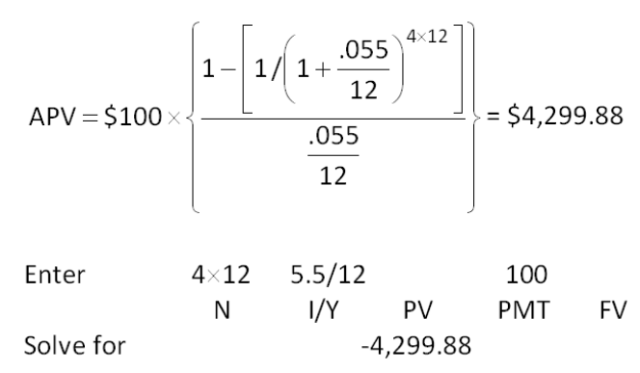

AACSB: Analytic
Bloom's: Application
Difficulty: Basic
Learning Objective: 6-1
Section: 6.2
Topic: Annuity present value
26. You just won the grand prize in a national writing contest! As your prize, you will receive $2,000 a month for ten years. If you can earn 7 percent on your money, what is this prize worth to you today?
A. $172,252.71
B. $178,411.06
C. $181,338.40
D. $185,333.33
E. $190,450.25
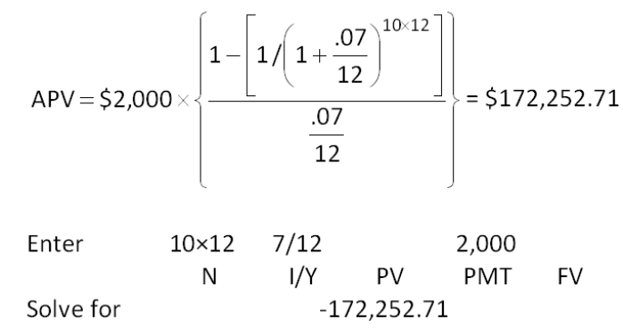

AACSB: Analytic
Bloom's: Application
Difficulty: Basic
Learning Objective: 6-1
Section: 6.2
Topic: Annuity present value
27. Phil can afford $180 a month for 5 years for a car loan. If the interest rate is 8.6 percent, how much can he afford to borrow to purchase a car?
A. $7,750.00
B. $8,348.03
C. $8,752.84
D. $9,266.67
E. $9,400.00
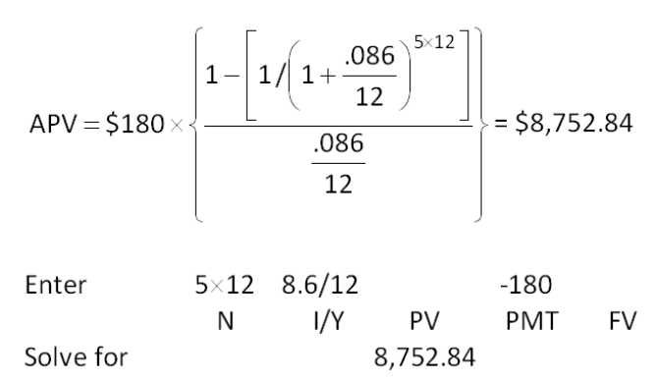

AACSB: Analytic
Bloom's: Application
Difficulty: Basic
Learning Objective: 6-2
Section: 6.2
Topic: Loan amount
28. You are the beneficiary of a life insurance policy. The insurance company informs you that you have two options for receiving the insurance proceeds. You can receive a lump sum of $200,000 today or receive payments of $1,400 a month for 20 years. You can earn 6 percent on your money. Which option should you take and why?
A. You should accept the payments because they are worth $209,414 to you today.
B. You should accept the payments because they are worth $247,800 to you today.
C. You should accept the payments because they are worth $336,000 to you today.
D. You should accept the $200,000 because the payments are only worth $189,311 to you today.
E. You should accept the $200,000 because the payments are only worth $195,413 to you today.
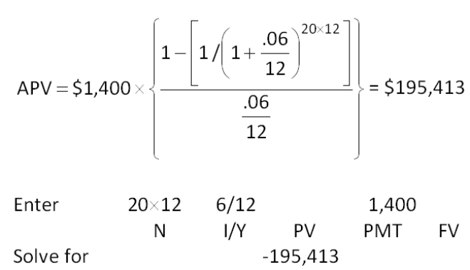

AACSB: Analytic
Bloom's: Application
Difficulty: Basic
Learning Objective: 6-2
Section: 6.2
Topic: Annuity present value
29. Your employer contributes $75 a week to your retirement plan. Assume that you work for your employer for another 20 years and that the applicable discount rate is 7.5 percent. Given these assumptions, what is this employee benefit worth to you today?
A. $40,384.69
B. $42,618.46
C. $44,211.11
D. $44,306.16
E. $44,987.74
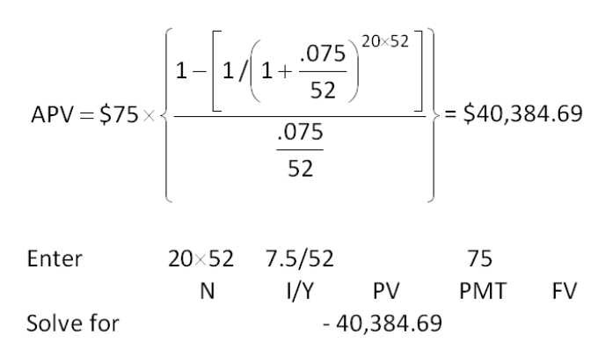

AACSB: Analytic
Bloom's: Application
Difficulty: Basic
Learning Objective: 6-2
Section: 6.2
Topic: Present value
30. The Design Team just decided to save $1,500 a month for the next 5 years as a safety net for recessionary periods. The money will be set aside in a separate savings account which pays 4.5 percent interest compounded monthly. The first deposit will be made today. What would today's deposit amount have to be if the firm opted for one lump sum deposit today that would yield the same amount of savings as the monthly deposits after 5 years?
A. $80,459.07
B. $80,760.79
C. $81,068.18
D. $81,333.33
E. $81,548.20
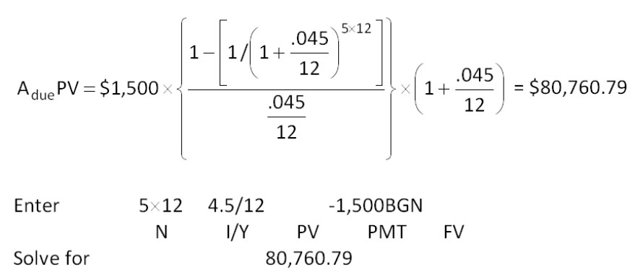

AACSB: Analytic
Bloom's: Application
Difficulty: Basic
Learning Objective: 6-2
Section: 6.2
Topic: Annuity due present value
31. You need some money today and the only friend you have that has any is your miserly friend. He agrees to loan you the money you need, if you make payments of $25 a month for the next six months. In keeping with his reputation, he requires that the first payment be paid today. He also charges you 1.5 percent interest per month. How much money are you borrowing?
A. $134.09
B. $138.22
C. $139.50
D. $142.68
E. $144.57
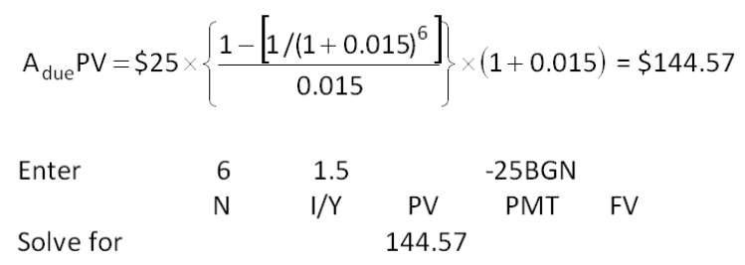

AACSB: Analytic
Bloom's: Application
Difficulty: Basic
Learning Objective: 6-2
Section: 6.2
Topic: Loan present value
32. You buy an annuity that will pay you $24,000 a year for 25 years. The payments are paid on the first day of each year. What is the value of this annuity today if the discount rate is 8.5 percent?
A. $241,309
B. $245,621
C. $251,409
D. $258,319
E. $266,498
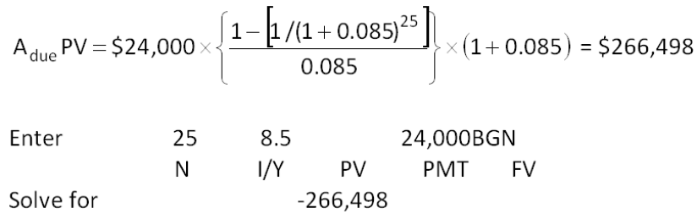

AACSB: Analytic
Bloom's: Application
Difficulty: Basic
Learning Objective: 6-2
Section: 6.2
Topic: Annuity due present value
33. You are scheduled to receive annual payments of $4,800 for each of the next 7 years. The discount rate is 8 percent. What is the difference in the present value if you receive these payments at the beginning of each year rather than at the end of each year?
A. $1,999
B. $2,013
C. $2,221
D. $2,227
E. $2,304
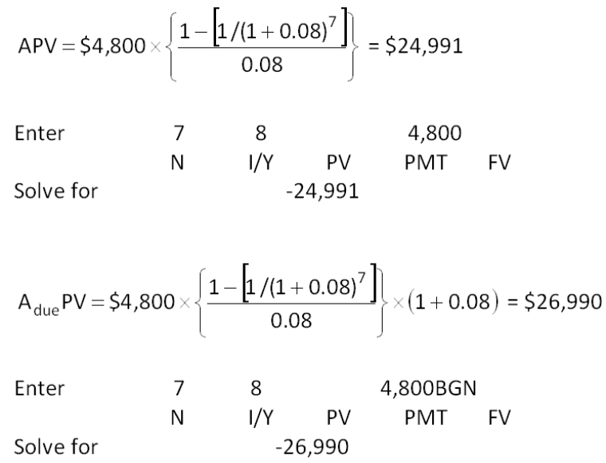
Difference = $26,990 - $24,991 = $1,999
Note: The difference = 0.08  $24,991 = $1,999

AACSB: Analytic
Bloom's: Analysis
Difficulty: Intermediate
Learning Objective: 6-1
Section: 6.2
Topic: Annuity present value
34. You are comparing two annuities with equal present values. The applicable discount rate is 8.75 percent. One annuity pays $5,000 on the first day of each year for 20 years. How much does the second annuity pay each year for 20 years if it pays at the end of each year?
A. $5,211
B. $5,267
C. $5,309
D. $5,390
E. $5,438
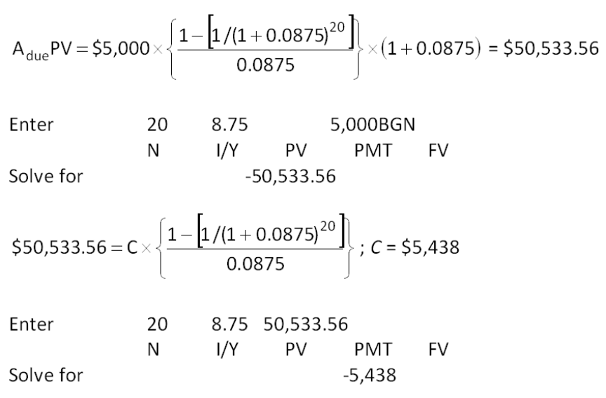
Because each payment is received one year later, then the cash flow has to equal:
$5,000  (1 + 0.0875) = $5,438

AACSB: Analytic
Bloom's: Analysis
Difficulty: Intermediate
Learning Objective: 6-2
Section: 6.2
Topic: Annuity comparison
35. Trish receives $480 on the first of each month. Josh receives $480 on the last day of each month. Both Trish and Josh will receive payments for next three years. At a 9.5 percent discount rate, what is the difference in the present value of these two sets of payments?
A. $118.63
B. $121.06
C. $124.30
D. $129.08
E. $132.50
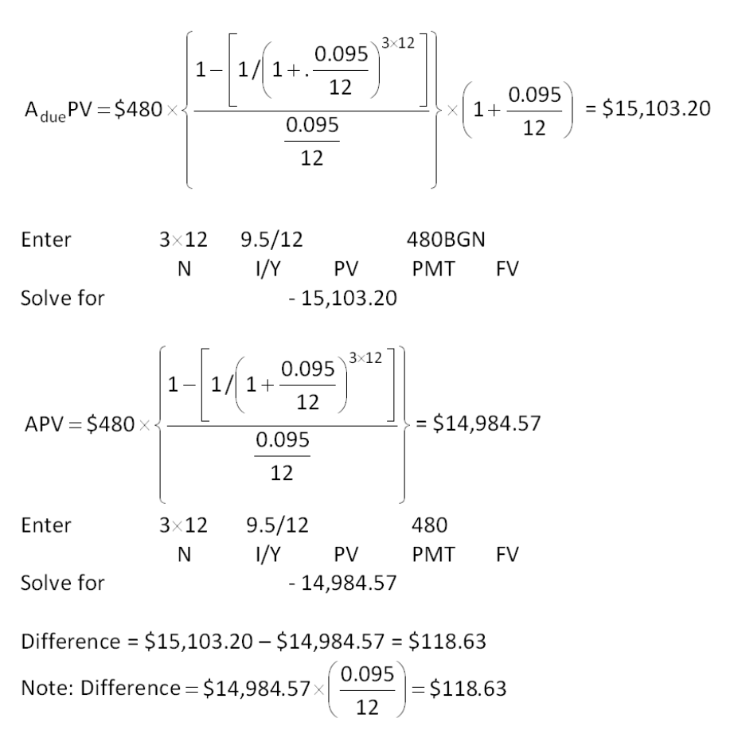

AACSB: Analytic
Bloom's: Analysis
Difficulty: Intermediate
Learning Objective: 6-2
Section: 6.2
Topic: Annuity comparison
36. What is the future value of $1,200 a year for 40 years at 8 percent interest? Assume annual compounding.
A. $301,115
B. $306,492
C. $310,868
D. $342,908
E. $347,267
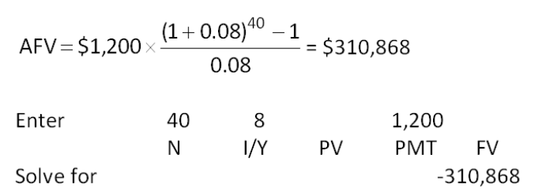

AACSB: Analytic
Bloom's: Application
Difficulty: Basic
Learning Objective: 6-2
Section: 6.2
Topic: Annuity future value
37. What is the future value of $15,000 a year for 30 years at 12 percent interest?
A. $2,878,406
B. $3,619,990
C. $3,711,414
D. $3,989,476
E. $4,021,223
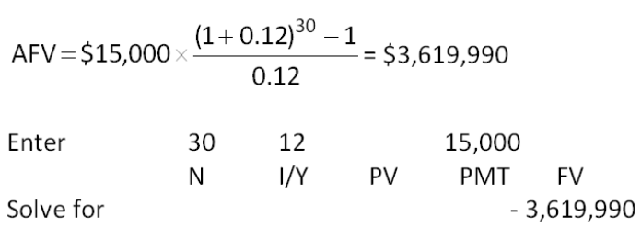

AACSB: Analytic
Bloom's: Application
Difficulty: Basic
Learning Objective: 6-2
Section: 6.2
Topic: Future value
38. Alexa plans on saving $3,000 a year and expects to earn an annual rate of 10.25 percent. How much will she have in her account at the end of 45 years?
A. $1,806,429
B. $1,838,369
C. $2,211,407
D. $2,333,572
E. $2,508,316
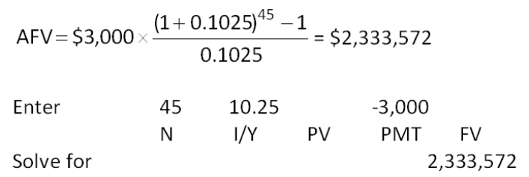

AACSB: Analytic
Bloom's: Application
Difficulty: Basic
Learning Objective: 6-2
Section: 6.2
Topic: Annuity future value
39. Theresa adds $1,000 to her savings account on the first day of each year. Marcus adds $1,000 to his savings account on the last day of each year. They both earn 6.5 percent annual interest. What is the difference in their savings account balances at the end of 35 years?
A. $8,062
B. $8,113
C. $8,127
D. $8,211
E. $8,219
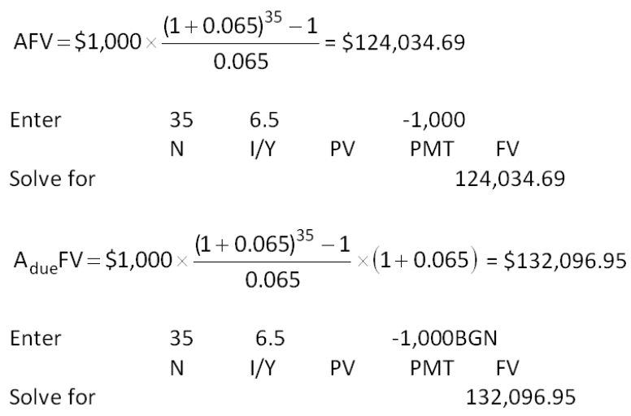
Difference = $132,096.95 - $124,034.69 = $8,062
Note: Difference = $124,034.69  0.065 = $8,062

AACSB: Analytic
Bloom's: Analysis
Difficulty: Intermediate
Learning Objective: 6-2
Section: 6.2
Topic: Annuity comparison
40. You are borrowing $17,800 to buy a car. The terms of the loan call for monthly payments for 5 years at 8.6 percent interest. What is the amount of each payment?
A. $287.71
B. $291.40
C. $301.12
D. $342.76
E. $366.05
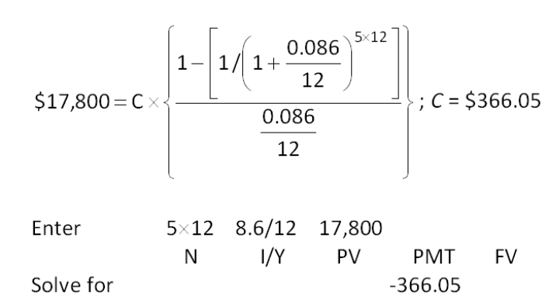

AACSB: Analytic
Bloom's: Application
Difficulty: Basic
Learning Objective: 6-2
Section: 6.2
Topic: Loan payment
41. You borrow $165,000 to buy a house. The mortgage rate is 7.5 percent and the loan period is 30 years. Payments are made monthly. If you pay the mortgage according to the loan agreement, how much total interest will you pay?
A. $206,408
B. $229,079
C. $250,332
D. $264,319
E. $291,406
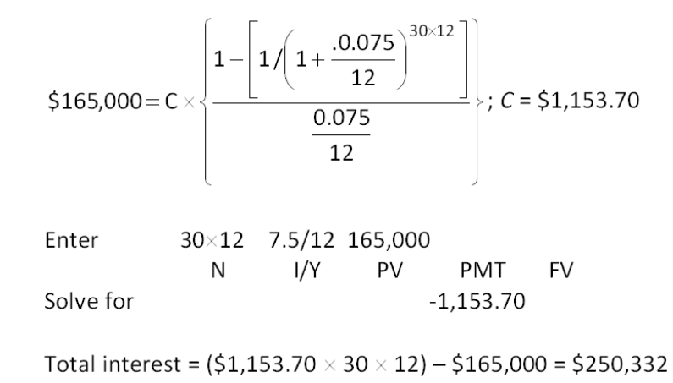

AACSB: Analytic
Bloom's: Analysis
Difficulty: Basic
Learning Objective: 6-2
Section: 6.2
Topic: Loan interest
42. Holiday Tours (HT) has an employment contract with its newly hired CEO. The contract requires a lump sum payment of $10.4 million be paid to the CEO upon the successful completion of her first three years of service. HT wants to set aside an equal amount of money at the end of each year to cover this anticipated cash outflow and will earn 5.65 percent on the funds. How much must HT set aside each year for this purpose?
A. $3,184,467
B. $3,277,973
C. $3,006,409
D. $3,318,190
E. $3,466,667
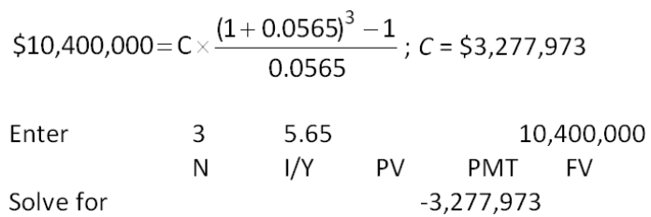

AACSB: Analytic
Bloom's: Application
Difficulty: Basic
Learning Objective: 6-2
Section: 6.2
Topic: Annuity payment
43. Nadine is retiring at age 62 and expects to live to age 85. On the day she retires, she has $348,219 in her retirement savings account. She is somewhat conservative with her money and expects to earn 6 percent during her retirement years. How much can she withdraw from her retirement savings each month if she plans to spend her last penny on the morning of her death?
A. $1,609.92
B. $1,847.78
C. $1,919.46
D. $2,116.08
E. $2,329.05
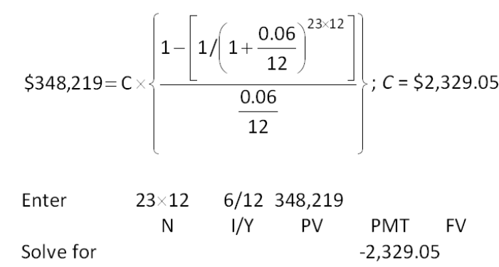

AACSB: Analytic
Bloom's: Application
Difficulty: Basic
Learning Objective: 6-2
Section: 6.2
Topic: Annuity payment
44. Kingston Development Corp. purchased a piece of property for $2.79 million. The firm paid a down payment of 15 percent in cash and financed the balance. The loan terms require monthly payments for 15 years at an annual percentage rate of 7.75 percent, compounded monthly. What is the amount of each mortgage payment?
A. $22,322.35
B. $23,419.97
C. $23,607.11
D. $24,878.15
E. $25,301.16
Amount financed = $2,790,000  (1 - 0.15) = $2,371,500
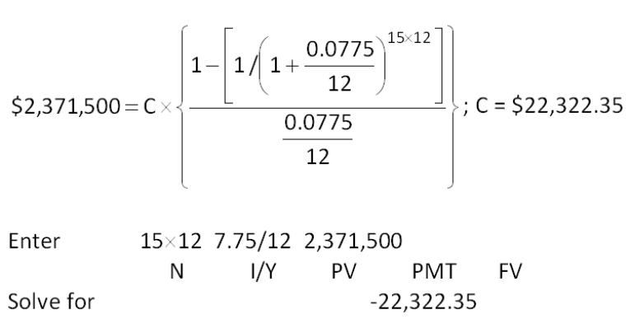

AACSB: Analytic
Bloom's: Application
Difficulty: Basic
Learning Objective: 6-2
Section: 6.2
Topic: Loan payment
45. You estimate that you will owe $42,800 in student loans by the time you graduate. The interest rate is 4.25 percent. If you want to have this debt paid in full within six years, how much must you pay each month?
A. $611.09
B. $674.50
C. $714.28
D. $736.05
E. $742.50
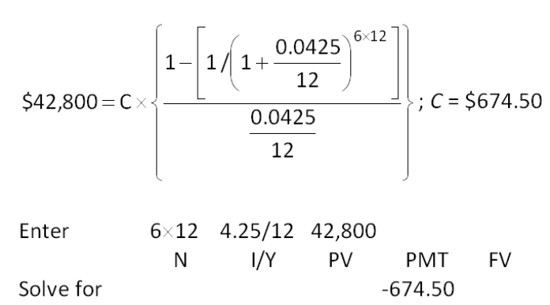

AACSB: Analytic
Bloom's: Application
Difficulty: Basic
Learning Objective: 6-2
Section: 6.2
Topic: Loan payment
46. You are buying a previously owned car today at a price of $3,500. You are paying $300 down in cash and financing the balance for 36 months at 8.5 percent. What is the amount of each loan payment?
A. $101.02
B. $112.23
C. $118.47
D. $121.60
E. $124.40
Amount financed = $3,500 - $300 = $3,200
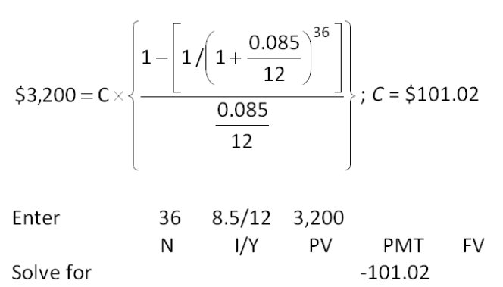

AACSB: Analytic
Bloom's: Application
Difficulty: Basic
Learning Objective: 6-2
Section: 6.2
Topic: Loan payment
47. Atlas Insurance wants to sell you an annuity which will pay you $3,400 per quarter for 25 years. You want to earn a minimum rate of return of 6.5 percent. What is the most you are willing to pay as a lump sum today to buy this annuity?
A. $151,008.24
B. $154,208.16
C. $167,489.11
D. $173,008.80
E. $178,927.59
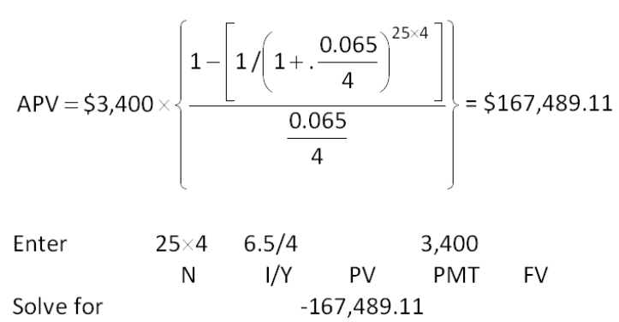

AACSB: Analytic
Bloom's: Application
Difficulty: Basic
Learning Objective: 6-2
Section: 6.2
Topic: Annuity present value
48. Your car dealer is willing to lease you a new car for $245 a month for 48 months. Payments are due on the first day of each month starting with the day you sign the lease contract. If your cost of money is 6.5 percent, what is the current value of the lease?
A. $10,331.03
B. $10,386.99
C. $12,197.74
D. $12,203.14
E. $13,008.31
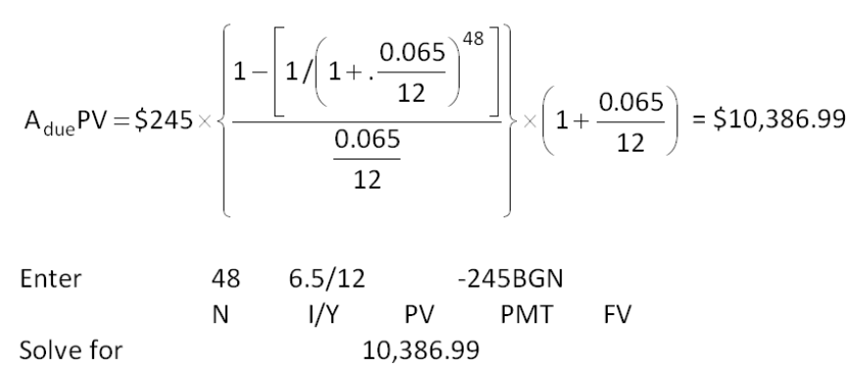

AACSB: Analytic
Bloom's: Application
Difficulty: Basic
Learning Objective: 6-2
Section: 6.2
Topic: Annuity present value
49. Your great aunt left you an inheritance in the form of a trust. The trust agreement states that you are to receive $3,600 on the first day of each year, starting immediately and continuing for 20 years. What is the value of this inheritance today if the applicable discount rate is 6.75 percent?
A. $38,890.88
B. $40,311.16
C. $41,516.01
D. $42,909.29
E. $43,333.33
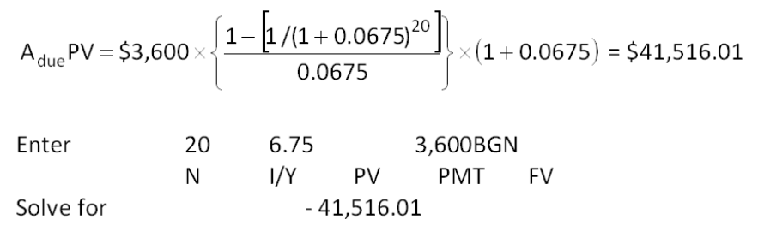

AACSB: Analytic
Bloom's: Application
Difficulty: Basic
Learning Objective: 6-2
Section: 6.2
Topic: Annuity due present value
50. You just received an insurance settlement offer related to an accident you had six years ago. The offer gives you a choice of one of the following three offers:
You can earn 7.5 percent on your investments. You do not care if you personally receive the funds or if they are paid to your heirs should you die within the settlement period. Which one of the following statements is correct given this information?
A. Option A is the best choice as it provides the largest monthly payment.
B. Option B is the best choice because it pays the largest total amount.
C. Option C is the best choice because it is has the largest current value.
D. Option B is the best choice because you will receive the most payments.
E. You are indifferent to the three options as they are all equal in value.
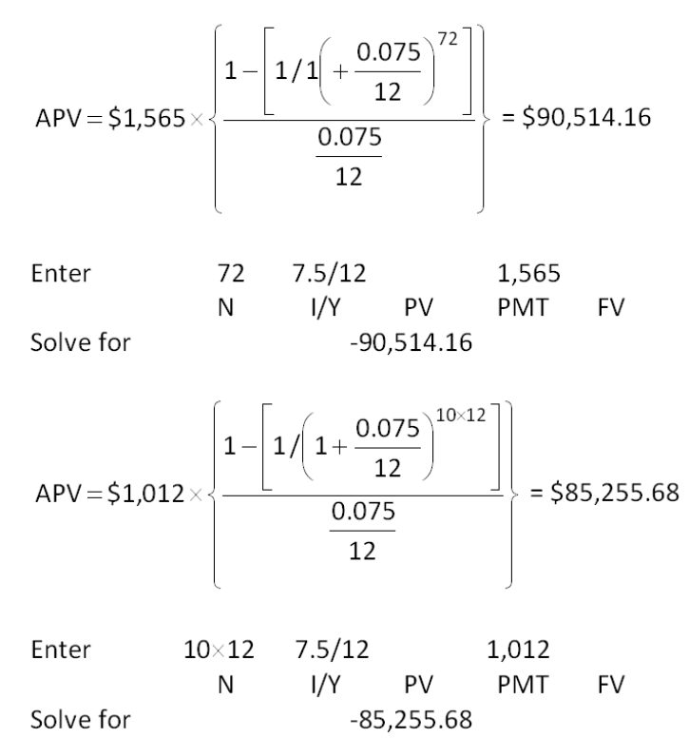
Option A has a present value of $90,514.16 at 7.5 percent.
Option B has a present value of $85,255.68 at 7.5 percent.
Option C has a present value of $100,000.
Option C is the best choice since it has the largest present value.

AACSB: Analytic
Bloom's: Analysis
Difficulty: Intermediate
Learning Objective: 6-2
Section: 6.2
Topic: Annuity present value
51. Samuelson Engines wants to save $750,000 to buy some new equipment six years from now. The plan is to set aside an equal amount of money on the first day of each quarter starting today. The firm can earn 4.75 percent on its savings. How much does the firm have to save each quarter to achieve its goal?
A. $26,872.94
B. $26,969.70
C. $27,192.05
D. $27,419.29
E. $27,911.08
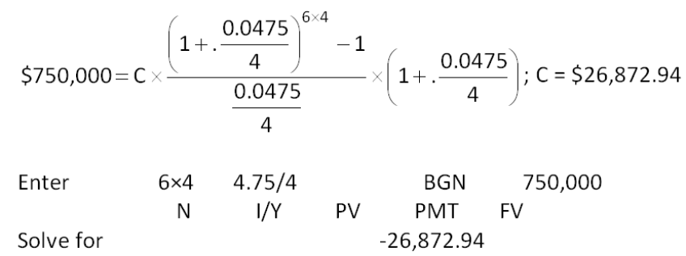

AACSB: Analytic
Bloom's: Application
Difficulty: Basic
Learning Objective: 6-2
Section: 6.2
Topic: Annuity due payment
52. Stephanie is going to contribute $300 on the first of each month, starting today, to her retirement account. Her employer will provide a 50 percent match. In other words, her employer will contribute 50 percent of the amount Stephanie saves. If both Stephanie and her employer continue to do this and she can earn a monthly rate of 0.90 percent, how much will she have in her retirement account 35 years from now?
A. $1,936,264
B. $1,943,286
C. $1,989,312
D. $2,068,418
E. $2,123,007
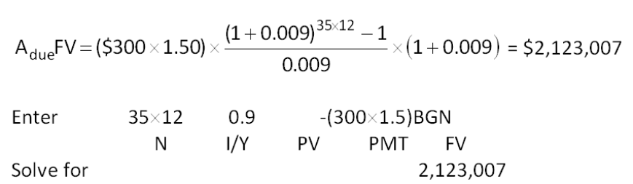

AACSB: Analytic
Bloom's: Application
Difficulty: Basic
Learning Objective: 6-2
Section: 6.2
Topic: Annuity future value
53. You are considering an annuity which costs $160,000 today. The annuity pays $18,126 a year at an annual interest rate of 7.50 percent. What is the length of the annuity time period?
A. 12 years
B. 13 years
C. 14 years
D. 15 years
E. 16 years
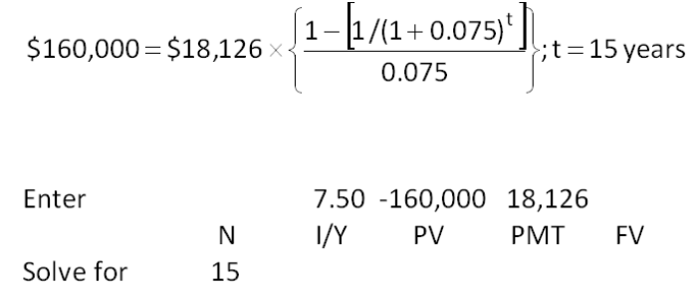

AACSB: Analytic
Bloom's: Application
Difficulty: Basic
Learning Objective: 6-2
Section: 6.2
Topic: Annuity time period
54. Today, you borrowed $6,200 on your credit card to purchase some furniture. The interest rate is 14.9 percent, compounded monthly. How long will it take you to pay off this debt assuming that you do not charge anything else and make regular monthly payments of $120?
A. 5.87 years
B. 6.40 years
C. 6.93 years
D. 7.23 years
E. 7.31 years
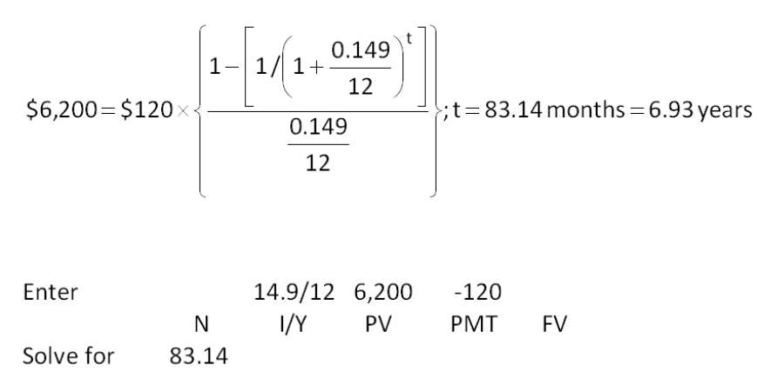
83.14 months/12 = 6.93 years

AACSB: Analytic
Bloom's: Application
Difficulty: Basic
Learning Objective: 6-2
Section: 6.2
Topic: Annuity payment
55. Meadow Brook Manor would like to buy some additional land and build a new assisted living center. The anticipated total cost is $23.6 million. The CEO of the firm is quite conservative and will only do this when the company has sufficient funds to pay cash for the entire construction project. Management has decided to save $1.2 million a quarter for this purpose. The firm earns 6.25 percent, compounded quarterly, on the funds it saves. How long does the company have to wait before expanding its operations?
A. 4.09 years
B. 4.32 years
C. 4.46 years
D. 4.82 years
E. 4.91 years
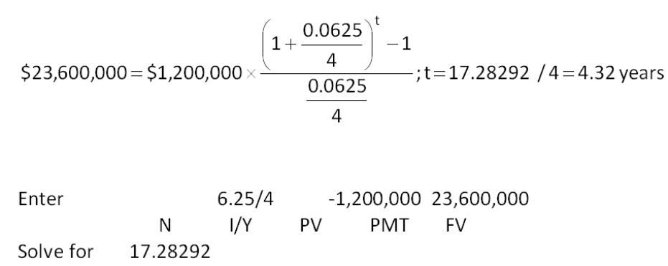
t = 17.28292 quarters/4 = 4.32 years

AACSB: Analytic
Bloom's: Application
Difficulty: Intermediate
Learning Objective: 6-2
Section: 6.2
Topic: Annuity time period
56. Today, you are retiring. You have a total of $411,016 in your retirement savings and have the funds invested such that you expect to earn an average of 7.10 percent, compounded monthly, on this money throughout your retirement years. You want to withdraw $2,500 at the beginning of every month, starting today. How long will it be until you run out of money?
A. 31.97 years
B. 34.56 years
C. 42.03 year
D. 48.19 years
E. You will never run out of money.
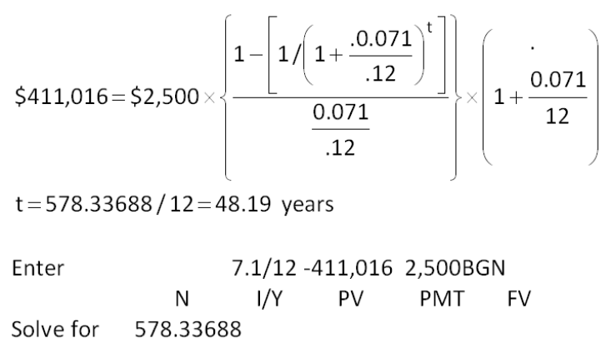
t = 578.33688 months/12 = 48.19 years

AACSB: Analytic
Bloom's: Application
Difficulty: Intermediate
Learning Objective: 6-2
Section: 6.2
Topic: Annuity time period
57. Gene's Art Gallery is notoriously known as a slow-payer. The firm currently needs to borrow $27,500 and only one company will even deal with them. The terms of the loan call for daily payments of $100. The first payment is due today. The interest rate is 21.9 percent, compounded daily. What is the time period of this loan? Assume a 365 day year.
A. 264.36 days
B. 280.81 days
C. 300.43 days
D. 316.46 days
E. 341.09 days
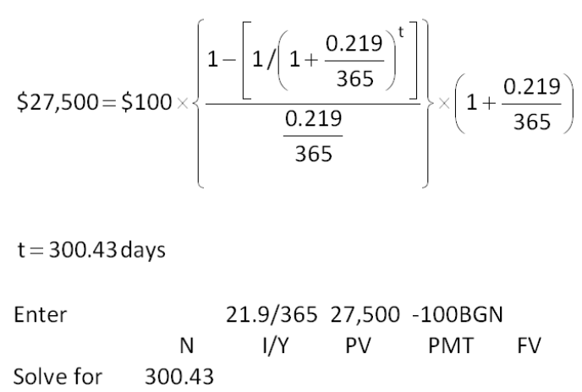

AACSB: Analytic
Bloom's: Application
Difficulty: Basic
Learning Objective: 6-2
Section: 6.2
Topic: Annuity time period
58. The Wine Press is considering a project which has an initial cash requirement of $187,400. The project will yield cash flows of $2,832 monthly for 84 months. What is the rate of return on this project?
A. 6.97 percent
B. 7.04 percent
C. 7.28 percent
D. 7.41 percent
E. 7.56 percent
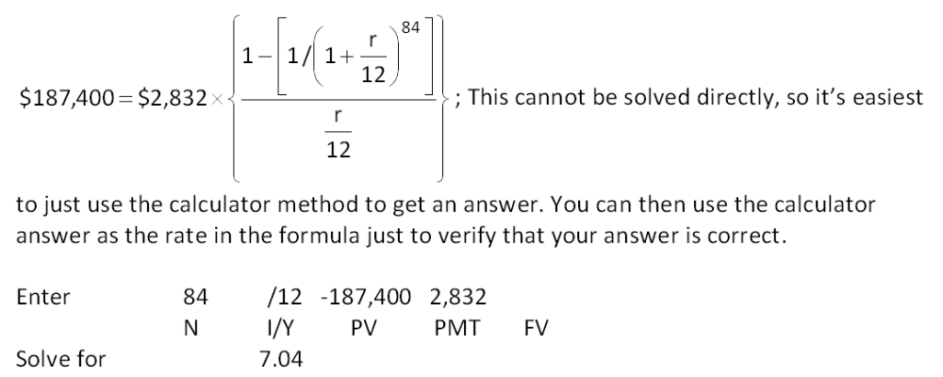

AACSB: Analytic
Bloom's: Application
Difficulty: Basic
Learning Objective: 6-2
Section: 6.2
Topic: Interest rate
59. Your insurance agent is trying to sell you an annuity that costs $200,000 today. By buying this annuity, your agent promises that you will receive payments of $1,225 a month for the next 30 years. What is the rate of return on this investment?
A. 5.75 percent
B. 5.97 percent
C. 6.20 percent
D. 6.45 percent
E. 6.67 percent
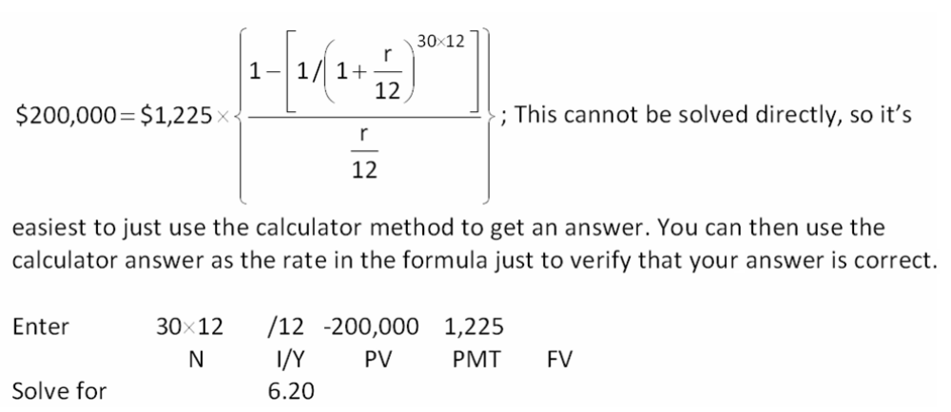

AACSB: Analytic
Bloom's: Application
Difficulty: Basic
Learning Objective: 6-2
Section: 6.2
Topic: Interest rate
60. You have been investing $250 a month for the last 13 years. Today, your investment account is worth $73,262. What is your average rate of return on your investments?
A. 8.94 percent
B. 9.23 percent
C. 9.36 percent
D. 9.41 percent
E. 9.78 percent
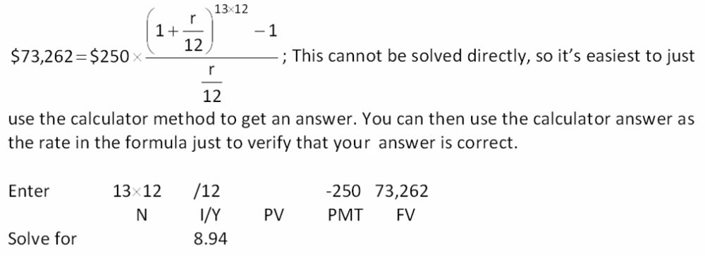

AACSB: Analytic
Bloom's: Application
Difficulty: Basic
Learning Objective: 6-2
Section: 6.2
Topic: Interest rate
61. Will has been purchasing $25,000 worth of New Tek stock annually for the past 11 years. His holdings are now worth $598,100. What is his annual rate of return on this stock?
A. 14.13 percent
B. 14.24 percent
C. 14.29 percent
D. 14.37 percent
E. 14.68 percent
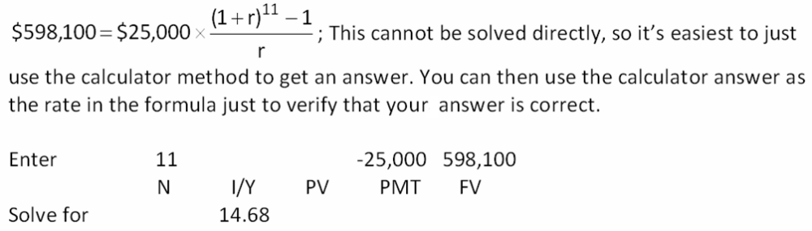

AACSB: Analytic
Bloom's: Application
Difficulty: Basic
Learning Objective: 6-2
Section: 6.2
Topic: Interest rate
62. Your father helped you start saving $20 a month beginning on your 5th birthday. He always made you deposit the money into your savings account on the first day of each month just to "start the month out right." Today completes your 17th year of saving and you now have $6,528.91 in this account. What is the rate of return on your savings?
A. 5.15 percent
B. 5.30 percent
C. 5.47 percent
D. 5.98 percent
E. 6.12 percent
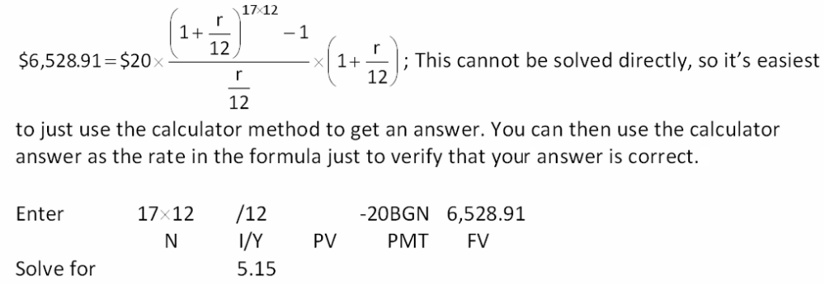

AACSB: Analytic
Bloom's: Application
Difficulty: Basic
Learning Objective: 6-2
Section: 6.2
Topic: Interest rate
63. Today, you turn 23. Your birthday wish is that you will be a millionaire by your 40th birthday. In an attempt to reach this goal, you decide to save $50 a day, every day until you turn 40. You open an investment account and deposit your first $50 today. What rate of return must you earn to achieve your goal?
A. 10.67 percent
B. 11.85 percent
C. 12.90 percent
D. 13.06 percent
E. 13.54 percent
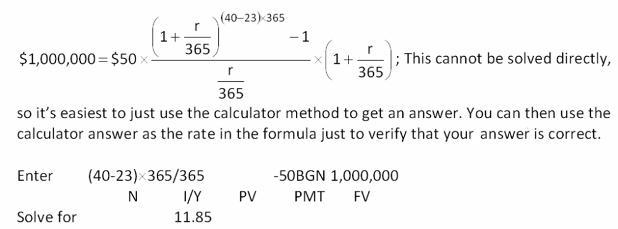

AACSB: Analytic
Bloom's: Application
Difficulty: Basic
Learning Objective: 6-2
Section: 6.2
Topic: Interest rate
64. You just settled an insurance claim. The settlement calls for increasing payments over a 10-year period. The first payment will be paid one year from now in the amount of $10,000. The following payments will increase by 4.5 percent annually. What is the value of this settlement to you today if you can earn 8 percent on your investments?
A. $76,408.28
B. $80,192.76
C. $82,023.05
D. $84,141.14
E. $85,008.16
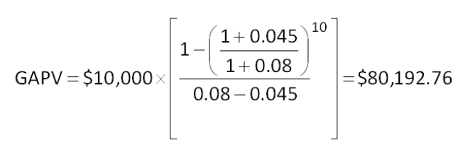

AACSB: Analytic
Bloom's: Application
Difficulty: Basic
Learning Objective: 6-2
Section: 6.2
Topic: Growing annuity
65. Your grandfather left you an inheritance that will provide an annual income for the next 10 years. You will receive the first payment one year from now in the amount of $4,000. Every year after that, the payment amount will increase by 6 percent. What is your inheritance worth to you today if you can earn 9.5 percent on your investments?
A. $31,699.15
B. $36,666.67
C. $41,121.21
D. $43,464.12
E. $46,908.17
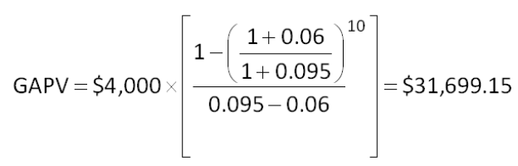

AACSB: Analytic
Bloom's: Application
Difficulty: Basic
Learning Objective: 6-2
Section: 6.2
Topic: Growing annuity
66. You just won a national sweepstakes! For your prize, you opted to receive never-ending payments. The first payment will be $12,500 and will be paid one year from today. Every year thereafter, the payments will increase by 3.5 percent annually. What is the present value of your prize at a discount rate of 8 percent?
A. $166,666.67
B. $248,409.19
C. $277,777.78
D. $291,006.12
E. $300,000.00
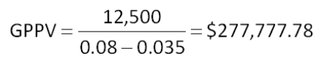

AACSB: Analytic
Bloom's: Application
Difficulty: Basic
Learning Objective: 6-2
Section: 6.2
Topic: Growing perpetuity
67. A wealthy benefactor just donated some money to the local college. This gift was established to provide scholarships for worthy students. The first scholarships will be granted one year from now for a total of $35,000. Annually thereafter, the scholarship amount will be increased by 5.5 percent to help offset the effects of inflation. The scholarship fund will last indefinitely. What is the value of this gift today at a discount rate of 8 percent?
A. $437,500
B. $750,000
C. $1,200,000
D. $1,400,000
E. $1,450,750
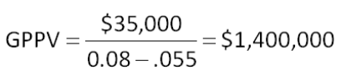

AACSB: Analytic
Bloom's: Application
Difficulty: Basic
Learning Objective: 6-2
Section: 6.2
Topic: Growing perpetuity
68. Southern Tours is considering acquiring Holiday Vacations. Management believes Holiday Vacations can generate cash flows of $187,000, $220,000, and $245,000 over the next three years, respectively. After that time, they feel the business will be worthless. Southern Tours has determined that a 13.5 percent rate of return is applicable to this potential acquisition. What is Southern Tours willing to pay today to acquire Holiday Vacations?
A. $503,098
B. $538,615
C. $545,920
D. $601,226
E. $638,407
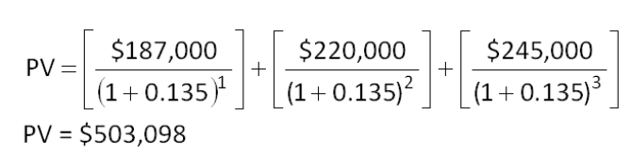

AACSB: Analytic
Bloom's: Application
Difficulty: Basic
Learning Objective: 6-1
Section: 6.1
Topic: Present value
69. You are considering two savings options. Both options offer a 7.4 percent rate of return. The first option is to save $900, $2,100, and $3,000 at the end of each year for the next three years, respectively. The other option is to save one lump sum amount today. If you want to have the same balance in your savings account at the end of the three years, regardless of the savings method you select, how much do you need to save today if you select the lump sum option?
A. $4,410
B. $4,530
C. $4,600
D. $5,080
E. $5,260
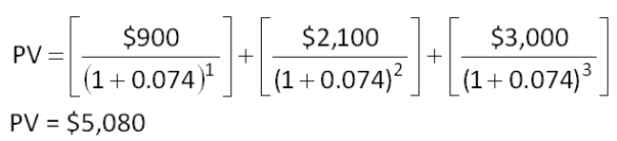

AACSB: Analytic
Bloom's: Application
Difficulty: Basic
Learning Objective: 6-1
Section: 6.1
Topic: Present value
70. Your parents have made you two offers. The first offer includes annual gifts of $10,000, $11,000, and $12,000 at the end of each of the next three years, respectively. The other offer is the payment of one lump sum amount today. You are trying to decide which offer to accept given the fact that your discount rate is 8 percent. What is the minimum amount that you will accept today if you are to select the lump sum offer?
A. $28,216
B. $29,407
C. $29,367
D. $30,439
E. $30,691
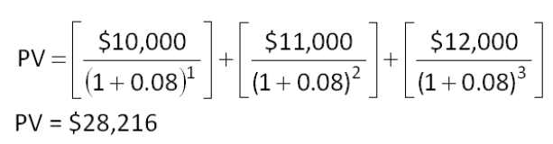

AACSB: Analytic
Bloom's: Application
Difficulty: Basic
Learning Objective: 6-1
Section: 6.1
Topic: Present value
71. You are considering changing jobs. Your goal is to work for three years and then return to school full-time in pursuit of an advanced degree. A potential employer just offered you an annual salary of $41,000, $44,000, and $46,000 a year for the next three years, respectively. All salary payments are made as lump sum payments at the end of each year. The offer also includes a starting bonus of $2,500 payable immediately. What is this offer worth to you today at a discount rate of 6.75 percent?
A. $112,406
B. $115,545
C. $117,333
D. $121,212
E. $134,697
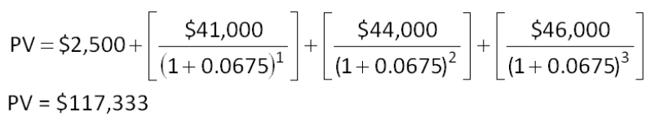

AACSB: Analytic
Bloom's: Application
Difficulty: Basic
Learning Objective: 6-1
Section: 6.1
Topic: Present value
72. You are considering a project which will provide annual cash inflows of $4,500, $5,700, and $8,000 at the end of each year for the next three years, respectively. What is the present value of these cash flows, given a 9 percent discount rate?
A. $14,877
B. $15,103
C. $15,429
D. $16,388
E. $16,847
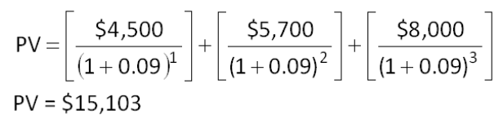

AACSB: Analytic
Bloom's: Application
Difficulty: Basic
Learning Objective: 6-1
Section: 6.1
Topic: Present value
73. You just signed a consulting contract that will pay you $35,000, $52,000, and $80,000 annually at the end of the next three years, respectively. What is the present value of these cash flows given a 10.5 percent discount rate?
A. $133,554
B. $142,307
C. $148,880
D. $151,131
E. $156,910
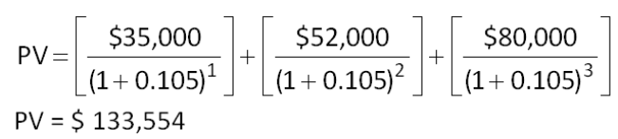

AACSB: Analytic
Bloom's: Application
Difficulty: Basic
Learning Objective: 6-1
Section: 6.1
Topic: Present value
74. You have some property for sale and have received two offers. The first offer is for $89,500 today in cash. The second offer is the payment of $35,000 today and an additional $70,000 two years from today. If the applicable discount rate is 11.5 percent, which offer should you accept and why?
A. You should accept the $89,500 today because it has the higher net present value.
B. You should accept the $89,500 today because it has the lower future value.
C. You should accept the first offer as it has the greatest value to you.
D. You should accept the second offer because it has the larger net present value.
E. It does not matter which offer you accept as they are equally valuable.
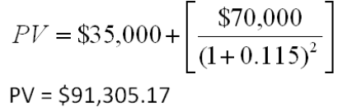

AACSB: Analytic
Bloom's: Application
Difficulty: Basic
Learning Objective: 6-1
Section: 6.1
Topic: Present value
75. Your local travel agent is advertising an upscale winter vacation package for travel three years from now to Antarctica. The package requires that you pay $25,000 today, $30,000 one year from today, and a final payment of $45,000 on the day you depart three years from today. What is the cost of this vacation in today's dollars if the discount rate is 9.75 percent?
A. $86,376
B. $89,695
C. $91,219
D. $91,407
E. $93,478
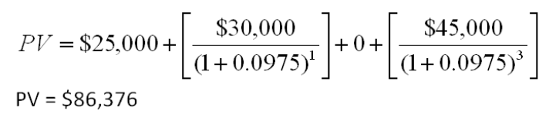

AACSB: Analytic
Bloom's: Application
Difficulty: Intermediate
Learning Objective: 6-1
Section: 6.1
Topic: Present value
76. One year ago, Deltona Motor Parts deposited $16,500 in an investment account for the purpose of buying new equipment three years from today. Today, it is adding another $12,000 to this account. The company plans on making a final deposit of $20,000 to the account one year from today. How much will be available when it is ready to buy the equipment, assuming the account pays 5.5 interest?
A. $53,408
B. $53,919
C. $56,211
D. $56,792
E. $58,021
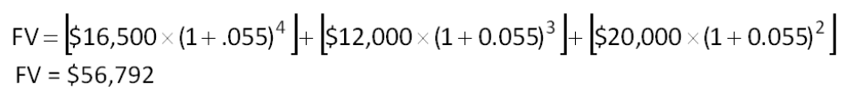

AACSB: Analytic
Bloom's: Analysis
Difficulty: Intermediate
Learning Objective: 6-1
Section: 6.1
Topic: Future value
77. Lucas will receive $6,800, $8,700, and $12,500 each year starting at the end of year one. What is the future value of these cash flows at the end of year five if the interest rate is 7 percent?
A. $32,418
B. $32,907
C. $33,883
D. $35,411
E. $36,255
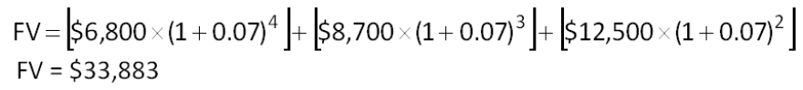

AACSB: Analytic
Bloom's: Analysis
Difficulty: Intermediate
Learning Objective: 6-1
Section: 6.1
Topic: Future value
78. You plan on saving $5,200 this year, nothing next year, and $7,500 the following year. You will deposit these amounts into your investment account at the end of each year. What will your investment account be worth at the end of year three if you can earn 8.5 percent on your funds?
A. $13,528.12
B. $13,621.57
C. $13,907.11
D. $14,526.50
E. $14,779.40
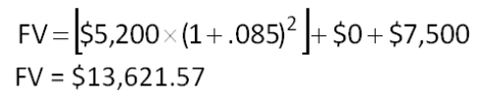

AACSB: Analytic
Bloom's: Analysis
Difficulty: Intermediate
Learning Objective: 6-1
Section: 6.1
Topic: Future value
79. Miley expects to receive the following payments: Year 1 = $60,000; Year 2 = $35,000; Year 3 = $12,000. All of this money will be saved for her retirement. If she can earn an average of 10.5 percent on her investments, how much will she have in her account 25 years after making her first deposit?
A. $972,373
B. $989,457
C. $1,006,311
D. $1,147,509
E. $1,231,776
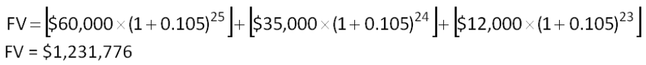

AACSB: Analytic
Bloom's: Application
Difficulty: Basic
Learning Objective: 6-1
Section: 6.1
Topic: Future value
80. Blackwell, Inc. has a $75,000 liability it must pay three years from today. The company is opening a savings account so that the entire amount will be available when this debt needs to be paid. The plan is to make an initial deposit today and then deposit an additional $15,000 each year for the next three years, starting one year from today. The account pays a 4.5 percent rate of return. How much does the firm need to deposit today?
A. $18,299.95
B. $20,072.91
C. $21,400.33
D. $24,487.78
E. $31,076.56
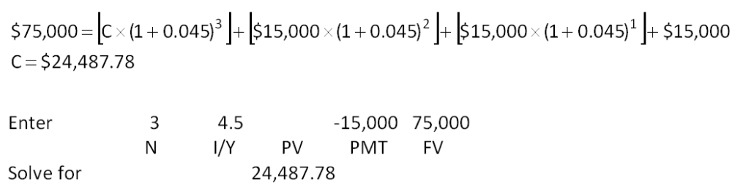

AACSB: Analytic
Bloom's: Application
Difficulty: Basic
Learning Objective: 6-1
Section: 6.1
Topic: Future value
81. The government has imposed a fine on the Corner Tavern. The fine calls for annual payments of $150,000, $100,000, $75,000, and $50,000, respectively, over the next four years. The first payment is due one year from today. The government plans to invest the funds until the final payment is collected and then donate the entire amount, including the investment earnings, to help the local community shelter. The government will earn 6.25 percent on the funds held. How much will the community shelter receive four years from today?
A. $349,674.06
B. $366,875.00
C. $422,497.56
D. $458,572.71
E. $515,737.67
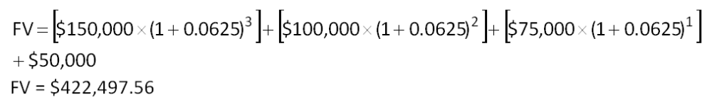

AACSB: Analytic
Bloom's: Application
Difficulty: Basic
Learning Objective: 6-1
Section: 6.1
Topic: Future value
82. Wicker Imports established a trust fund that provides $90,000 in scholarships each year for needy students. The trust fund earns a fixed 6 percent rate of return. How much money did the firm contribute to the fund assuming that only the interest income is distributed?
A. $1,150,000
B. $1,200,000
C. $1,333,333
D. $1,500,000
E. $1,600,000
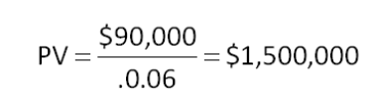

AACSB: Analytic
Bloom's: Application
Difficulty: Basic
Learning Objective: 6-1
Section: 6.2
Topic: Perpetuity present value
83. A preferred stock pays an annual dividend of $2.60. What is one share of this stock worth today if the rate of return is 11.75 percent?
A. $18.48
B. $20.00
C. $22.13
D. $28.80
E. $30.55
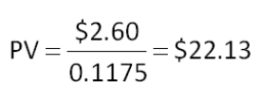

AACSB: Analytic
Bloom's: Application
Difficulty: Basic
Learning Objective: 6-1
Section: 6.2
Topic: Perpetuity present value
84. You would like to establish a trust fund that will provide $120,000 a year forever for your heirs. The trust fund is going to be invested very conservatively so the expected rate of return is only 5.75 percent. How much money must you deposit today to fund this gift for your heirs?
A. $2,086,957
B. $2,121,212
C. $2,300,000
D. $2,458,122
E. $2,500,000
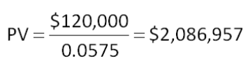

AACSB: Analytic
Bloom's: Application
Difficulty: Basic
Learning Objective: 6-1
Section: 6.2
Topic: Perpetuity present value
85. You just paid $750,000 for an annuity that will pay you and your heirs $45,000 a year forever. What rate of return are you earning on this policy?
A. 5.25 percent
B. 5.50 percent
C. 5.75 percent
D. 6.00 percent
E. 6.25 percent
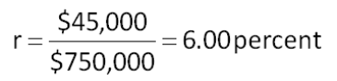

AACSB: Analytic
Bloom's: Application
Difficulty: Basic
Learning Objective: 6-2
Section: 6.2
Topic: Perpetuity
86. You grandfather won a lottery years ago. The value of his winnings at the time was $50,000. He invested this money such that it will provide annual payments of $2,400 a year to his heirs forever. What is the rate of return?
A. 4.75 percent
B. 4.80 percent
C. 5.00 percent
D. 5.10 percent
E. 5.15 percent
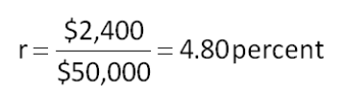

AACSB: Analytic
Bloom's: Application
Difficulty: Basic
Learning Objective: 6-2
Section: 6.2
Topic: Perpetuity rate
87. The preferred stock of Casco has a 5.48 percent dividend yield. The stock is currently priced at $59.30 per share. What is the amount of the annual dividend?
A. $2.80
B. $2.95
C. $3.10
D. $3.25
E. $3.40
C = $59.30  0.0548 = $3.25

AACSB: Analytic
Bloom's: Application
Difficulty: Basic
Learning Objective: 6-2
Section: 6.2
Topic: Annuity payment
88. Your credit card company charges you 1.65 percent interest per month. What is the annual percentage rate on your account?
A. 18.95 percent
B. 19.80 percent
C. 20.90 percent
D. 21.25 percent
E. 21.70 percent
APR = 0.0165  12 = 19.80 percent

AACSB: Analytic
Bloom's: Application
Difficulty: Basic
Learning Objective: 6-4
Section: 6.3
Topic: Annual percentage rate
89. What is the annual percentage rate on a loan with a stated rate of 2.25 percent per quarter?
A. 9.00 percent
B. 9.09 percent
C. 9.18 percent
D. 9.27 percent
E. 9.31 percent
APR = 0.0225  4 = 9.00 percent

AACSB: Analytic
Bloom's: Application
Difficulty: Basic
Learning Objective: 6-4
Section: 6.3
Topic: Annual percentage rate
90. You are paying an effective annual rate of 18.974 percent on your credit card. The interest is compounded monthly. What is the annual percentage rate on this account?
A. 17.50 percent
B. 18.00 percent
C. 18.25 percent
D. 18.64 percent
E. 19.00 percent
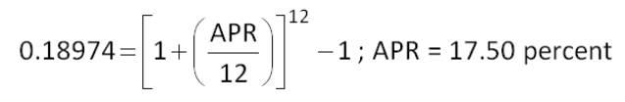

AACSB: Analytic
Bloom's: Application
Difficulty: Basic
Learning Objective: 6-4
Section: 6.3
Topic: Annual percentage rate
91. What is the effective annual rate if a bank charges you 9.50 percent compounded quarterly?
A. 9.62 percent
B. 9.68 percent
C. 9.72 percent
D. 9.84 percent
E. 9.91 percent
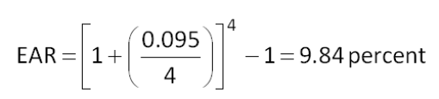

AACSB: Analytic
Bloom's: Application
Difficulty: Basic
Learning Objective: 6-4
Section: 6.3
Topic: Effective annual rate
92. Your credit card company quotes you a rate of 17.9 percent. Interest is billed monthly. What is the actual rate of interest you are paying?
A. 19.03 percent
B. 19.21 percent
C. 19.44 percent
D. 19.57 percent
E. 19.72 percent
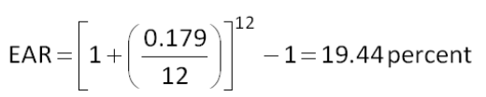

AACSB: Analytic
Bloom's: Application
Difficulty: Basic
Learning Objective: 6-4
Section: 6.3
Topic: Effective interest rate
93. The Pawn Shop loans money at an annual rate of 21 percent and compounds interest weekly. What is the actual rate being charged on these loans?
A. 23.16 percent
B. 23.32 percent
C. 23.49 percent
D. 23.56 percent
E. 23.64 percent
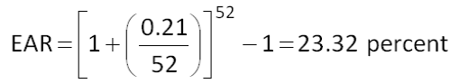

AACSB: Analytic
Bloom's: Application
Difficulty: Basic
Learning Objective: 6-4
Section: 6.3
Topic: Effective annual rate
94. You are considering two loans. The terms of the two loans are equivalent with the exception of the interest rates. Loan A offers a rate of 7.75 percent, compounded daily. Loan B offers a rate of 8 percent, compounded semi-annually. Which loan should you select and why?
A. A; the effective annual rate is 8.06 percent.
B. A; the annual percentage rate is 7.75 percent.
C. B; the annual percentage rate is 7.68 percent.
D. B; the effective annual rate is 8.16 percent.
E. The loans are equivalent offers so you can select either one.
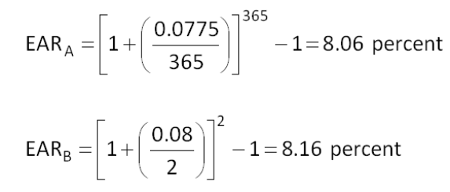

AACSB: Analytic
Bloom's: Analysis
Difficulty: Intermediate
Learning Objective: 6-4
Section: 6.3
Topic: Effective annual rate
95. You have $5,600 that you want to use to open a savings account. There are five banks located in your area. The rates paid by banks A through E, respectively, are given below. Which bank should you select if your goal is to maximize your interest income?
A. 3.26 percent, compounded annually
B. 3.20 percent, compounded monthly
C. 3.25 percent, compounded semi-annually
D. 3.10 percent, compounded continuously
E. 3.15 percent, compounded quarterly
EAR_{A} = 3.26 percent
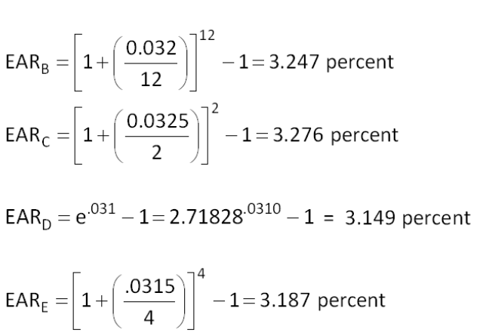
Bank C offers the highest effective annual rate at 3.276 percent.

AACSB: Analytic
Bloom's: Analysis
Difficulty: Intermediate
Learning Objective: 6-4
Section: 6.3
Topic: Effective annual rate
96. What is the effective annual rate of 14.9 percent compounded continuously?
A. 15.59 percent
B. 15.62 percent
C. 15.69 percent
D. 15.84 percent
E. 16.07 percent

AACSB: Analytic
Bloom's: Application
Difficulty: Basic
Learning Objective: 6-4
Section: 6.3
Topic: Continuous compounding
97. What is the effective annual rate of 9.75 percent compounded continuously?
A. 10.17 percent
B. 10.24 percent
C. 10.29 percent
D. 10.33 percent
E. 10.47 percent

AACSB: Analytic
Bloom's: Application
Difficulty: Basic
Learning Objective: 6-4
Section: 6.3
Topic: Continuous compounding
98. City Bank wants to appear competitive based on quoted loan rates and thus must offer a 7.75 percent annual percentage rate on its loans. What is the maximum rate the bank can actually earn based on the quoted rate?
A. 8.06 percent
B. 8.14 percent
C. 8.21 percent
D. 8.26 percent
E. 8.58 percent

AACSB: Analytic
Bloom's: Application
Difficulty: Basic
Learning Objective: 6-4
Section: 6.3
Topic: Continuous compounding
99. You are going to loan a friend $900 for one year at a 5 percent rate of interest, compounded annually. How much additional interest could you have earned if you had compounded the rate continuously rather than annually?
A. $0.97
B. $1.14
C. $1.23
D. $1.36
E. $1.41
Additional interest = $900  (0.0512711 - 0.05) = $1.14

AACSB: Analytic
Bloom's: Analysis
Difficulty: Intermediate
Learning Objective: 6-4
Section: 6.3
Topic: Interest compounding
100. You are borrowing money today at 8.48 percent, compounded annually. You will repay the principal plus all the interest in one lump sum of $12,800 two years from today. How much are you borrowing?
A. $9,900.00
B. $10,211.16
C. $10,877.04
D. $11,401.16
E. $11,250.00
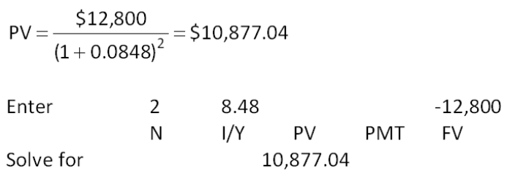

AACSB: Analytic
Bloom's: Application
Difficulty: Basic
Learning Objective: 6-2
Section: 6.4
Topic: Pure discount loan
101. This morning, you borrowed $9,500 at 7.65 percent annual interest. You are to repay the loan principal plus all of the loan interest in one lump sum four years from today. How much will you have to repay?
A. $12,757.92
B. $12,808.13
C. $12,911.89
D. $13,006.08
E. $13,441.20
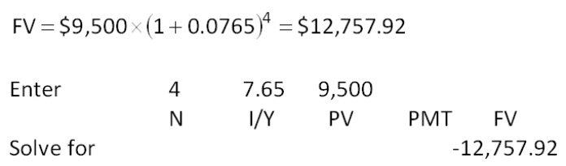

AACSB: Analytic
Bloom's: Application
Difficulty: Basic
Learning Objective: 6-3
Section: 6.4
Topic: Pure discount loan
102. On this date last year, you borrowed $3,400. You have to repay the loan principal plus all of the interest six years from today. The payment that is required at that time is $6,000. What is the interest rate on this loan?
A. 8.01 percent
B. 8.45 percent
C. 8.78 percent
D. 9.47 percent
E. 9.93 percent
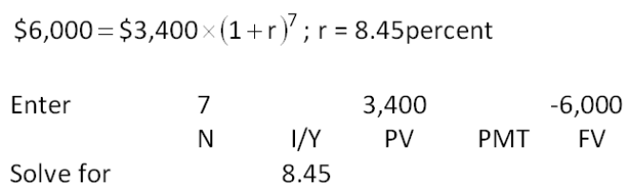

AACSB: Analytic
Bloom's: Application
Difficulty: Basic
Learning Objective: 6-3
Section: 6.4
Topic: Pure discount loan
103. John's Auto Repair just took out an $89,000, 10-year, 8 percent, interest-only loan from the bank. Payments are made annually. What is the amount of the loan payment in year 10?
A. $7,120
B. $8,850
C. $13,264
D. $89,000
E. $96,120
Payment in year 10 = $89,000 + ($89,000  0.08) = $96,120

AACSB: Analytic
Bloom's: Application
Difficulty: Basic
Learning Objective: 6-3
Section: 6.4
Topic: Interest-only loan
104. On the day you entered college, you borrowed $18,000 on an interest-only, four-year loan at 5.25 percent from your local bank. Payments are to be paid annually. What is the amount of your loan payment in year 2?
A. $945
B. $1,890
C. $3,600
D. $5,106
E. $6,250
Payment in year 2 = $18,000  0.0525 = $945

AACSB: Analytic
Bloom's: Application
Difficulty: Basic
Learning Objective: 6-3
Section: 6.4
Topic: Interest-only loan
105. On the day you entered college you borrowed $25,000 from your local bank. The terms of the loan include an interest rate of 4.75 percent. The terms stipulate that the principal is due in full one year after you graduate. Interest is to be paid annually at the end of each year. Assume that you complete college in four years. How much total interest will you pay on this loan?
A. $5,266.67
B. $5,400.00
C. $5,937.50
D. $6,529.00
E. $6,607.11
Total interest paid = $25,000  0.0475  5 = $5,937.50

AACSB: Analytic
Bloom's: Application
Difficulty: Basic
Learning Objective: 6-3
Section: 6.4
Topic: Interest-only loan
106. You just acquired a mortgage in the amount of $249,500 at 6.75 percent interest, compounded monthly. Equal payments are to be made at the end of each month for thirty years. How much of the first loan payment is interest? (Assume each month is equal to 1/12 of a year.)
A. $925.20
B. $1,206.16
C. $1,403.44
D. $1,511.21
E. $1,548.60
Interest portion of first loan payment = 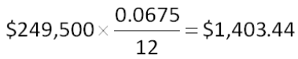

AACSB: Analytic
Bloom's: Analysis
Difficulty: Intermediate
Learning Objective: 6-3
Section: 6.4
Topic: Amortized loan
107. On June 1, you borrowed $212,000 to buy a house. The mortgage rate is 8.25 percent. The loan is to be repaid in equal monthly payments over 15 years. The first payment is due on July 1. How much of the second payment applies to the principal balance? (Assume that each month is equal to 1/12 of a year.)
A. $603.32
B. $698.14
C. $1,358.56
D. $1,453.38
E. $2,056.70
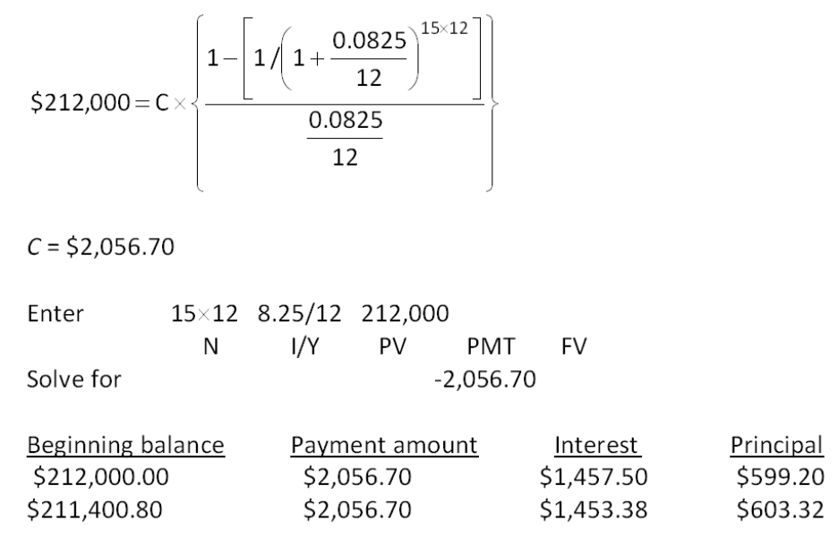

AACSB: Analytic
Bloom's: Analysis
Difficulty: Intermediate
Learning Objective: 6-3
Section: 6.2
Topic: Amortized loan
108. This morning, you borrowed $150,000 to buy a house. The mortgage rate is 7.35 percent. The loan is to be repaid in equal monthly payments over 20 years. The first payment is due one month from today. How much of the second payment applies to the principal balance? (Assume that each month is equal to 1/12 of a year.)
A. $268.84
B. $277.61
C. $917.06
D. $925.83
E. $1,194.67
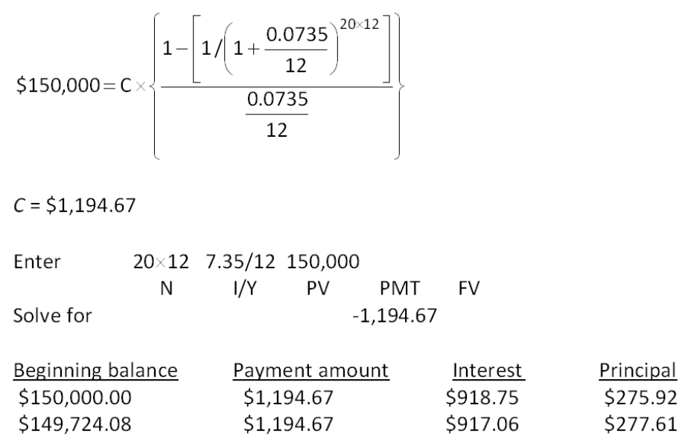

AACSB: Analytic
Bloom's: Analysis
Difficulty: Intermediate
Learning Objective: 6-3
Section: 6.2
Topic: Amortized loan

Essay Questions
109. Explain the difference between the effective annual rate (EAR) and the annual percentage rate (APR). Of the two, which one has the greater importance and why?
The APR is a stated rate and is computed as (r  n), where r is the rate per period and n is the number of periods per year. The EAR considers compounding and is computed as (1 + r)^{n} - 1, where r is the rate per period and n is the number of periods per year. The effective annual rate will always be higher than the annual percentage rate as long as the account is compounded more than once a year and the interest rate is greater than zero. The EAR is the equivalent rate based on annual compounding. The EAR has greater importance because it is the actual cost of a loan.
Feedback: Refer to section 6.3

AACSB: Reflective thinking
Bloom's: Analysis
Difficulty: Intermediate
Learning Objective: 6-4
Section: 6.3
Topic: Annual and effective rates
110. You are considering two annuities, both of which pay a total of $20,000 over the life of the annuity. Annuity A pays $2,000 at the end of each year for the next 10 years. Annuity B pays $1,000 at the end of each year for the next 20 years. Which annuity has the greater value today? Is there any circumstance where the two annuities would have equal values as of today? Explain.
As long as the discount rate is positive, Annuity A will have the greater value. If the discount rate is zero, then both annuities have equal values as both would have a current value of $20,000.
Feedback: Refer to section 6.2

AACSB: Reflective thinking
Bloom's: Analysis
Difficulty: Intermediate
Learning Objective: 6-2
Section: 6.2
Topic: Annuity present value
111. Why might a borrower select an interest-only loan instead of an amortized loan, which would be cheaper?
The borrower might need the entire principal amount for the length of the loan period. With an amortized loan, the principal amount is repaid over the loan term and thus the borrower does not have all of the loan proceeds available for his or her use during the loan term.
Feedback: Refer to section 6.4

AACSB: Reflective thinking
Bloom's: Synthesis
Difficulty: Intermediate
Learning Objective: 6-3
Section: 6.4
Topic: Loan repayment
112. Kristie owns a perpetuity which pays $12,000 at the end of each year. She comes to you and offers to sell you all of the payments to be received after the 10th year. Explain how you can determine the value of this offer.
You should determine the present value of the perpetuity and also the present value of the first 10 payments at your discount rate. The difference between the two values is the maximum amount you should pay for this offer. (Assuming a normal rate of interest, the offer will most likely be worth less than 50 percent of the perpetuity's total value.)
Here's an example that can be used to explain this answer using an assumed 8 percent rate of interest.
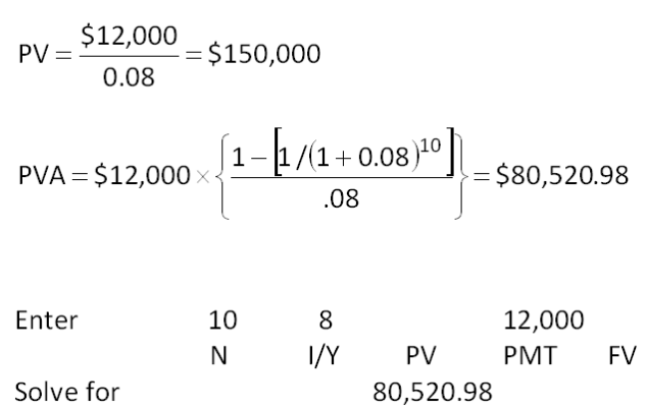
Value of offer at 8 percent = $150,000 - $80,520.98 = $69,479.02
Feedback: Refer to section 6.2

AACSB: Analytic and reflective thinking
Bloom's: Evaluation
Difficulty: Intermediate
Learning Objective: 6-2
Section: 6.2
Topic: Perpetuity and annuity values

Multiple Choice Questions
113. Western Bank offers you a $21,000, 6-year term loan at 8 percent annual interest. What is the amount of your annual loan payment?
A. $4,228.50
B. $4,542.62
C. $4,666.67
D. $4,901.18
E. $5,311.07
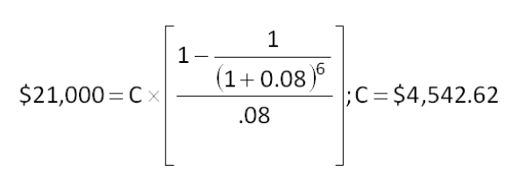

AACSB: Analytic
Bloom's: Application
Difficulty: Basic
EOC #: 6-9
Learning Objective: 6-2
Section: 6.2
Topic: Loan payment
114. First Century Bank wants to earn an effective annual return on its consumer loans of 10 percent per year. The bank uses daily compounding on its loans. By law, what interest rate is the bank required to report to potential borrowers?
A. 9.23 percent
B. 9.38 percent
C. 9.53 percent
D. 9.72 percent
E. 10.00 percent
APR = 365  [(1 + 0.10)^{1/365} - 1] = 9.53 percent

AACSB: Analytic
Bloom's: Application
Difficulty: Intermediate
EOC #: 6-15
Learning Objective: 6-4
Section: 6.3
Topic: Interest rate
115. Downtown Bank is offering 3.4 percent compounded daily on its savings accounts. You deposit $8,000 today. How much will you have in your account 11 years from now?
A. $11,628.09
B. $11,714.06
C. $12,204.50
D. $12,336.81
E. $12,414.14
FV = $8,000  [1 + (0.034/365)]¹¹ ^{ 365} = $11,628.09

AACSB: Analytic
Bloom's: Application
Difficulty: Basic
EOC #: 6-17
Learning Objective: 6-1
Section: 6.1
Topic: Future value
116. You want to buy a new sports coupe for $41,750, and the finance office at the dealership has quoted you an 8.6 percent APR loan compounded monthly for 48 months to buy the car. What is the effective interest rate on this loan?
A. 8.28 percent
B. 8.41 percent
C. 8.72 percent
D. 8.87 percent
E. 8.95 percent
EAR = [1 + (.086/12)]¹² - 1 = 8.95 percent

AACSB: Analytic
Bloom's: Application
Difficulty: Basic
EOC #: 6-20
Learning Objective: 6-4
Section: 6.3
Topic: Effective interest rate
117. Beginning three months from now, you want to be able to withdraw $1,500 each quarter from your bank account to cover college expenses over the next 4 years. The account pays 1.25 percent interest per quarter. How much do you need to have in your account today to meet your expense needs over the next 4 years?
A. $21,630.44
B. $21,847.15
C. $22,068.00
D. $22,454.09
E. $22,711.18
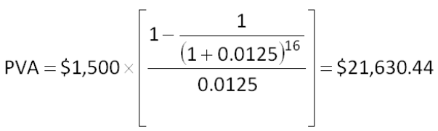

AACSB: Analytic
Bloom's: Application
Difficulty: Basic
EOC #: 6-26
Learning Objective: 6-1
Section: 6.1
Topic: Present value
118. You are planning to save for retirement over the next 15 years. To do this, you will invest $1,100 a month in a stock account and $500 a month in a bond account. The return on the stock account is expected to be 7 percent, and the bond account will pay 4 percent. When you retire, you will combine your money into an account with a 5 percent return. How much can you withdraw each month during retirement assuming a 20-year withdrawal period?
A. $2,636.19
B. $2,904.11
C. $3,008.21
D. $3,113.04
E. $3,406.97
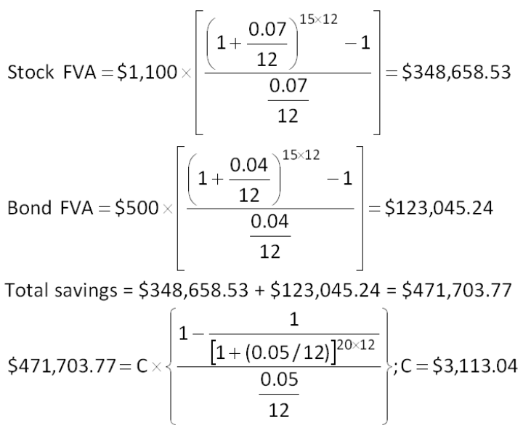

AACSB: Analytic
Bloom's: Analysis
Difficulty: Intermediate
EOC #: 6-32
Learning Objective: 6-2
Section: 6.2
Topic: Annuity payment
119. You want to be a millionaire when you retire in 40 years. You can earn an 11 percent annual return. How much more will you have to save each month if you wait 10 years to start saving versus if you start saving at the end of this month?
A. $79.22
B. $114.13
C. $168.47
D. $201.15
E. $240.29
FVA_{40 years} = $1,000,000 = C  [{[1 + (0.11/12)]⁴⁰ ^{ 12}; C = $116.28
FVA_{30 years} = $1,000,000 = C  [{[1 + (0.11/12)]³⁰ ^{ 12}; C = $356.57
Difference = $356.57 - $116.28 = $240.29

AACSB: Analytic
Bloom's: Analysis
Difficulty: Intermediate
EOC #: 6-34
Learning Objective: 6-2
Section: 6.2
Topic: Annuity payment
120. You have just won the lottery and will receive $540,000 as your first payment one year from now. You will receive payments for 26 years. The payments will increase in value by 4 percent each year. The appropriate discount rate is 10 percent. What is the present value of your winnings?
A. $6,221,407
B. $6,906,372
C. $7,559,613
D. $7,811,406
E. $8,003.11
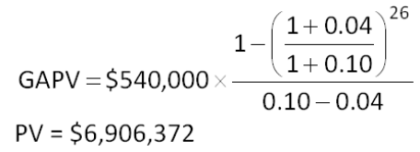

AACSB: Analytic
Bloom's: Application
Difficulty: Intermediate
EOC #: 6-37
Learning Objective: 6-2
Section: 6.2
Topic: Growing annuity
121. You are preparing to make monthly payments of $65, beginning at the end of this month, into an account that pays 6 percent interest compounded monthly. How many payments will you have made when your account balance reaches $9,278?
A. 97
B. 108
C. 119
D. 124
E. 131
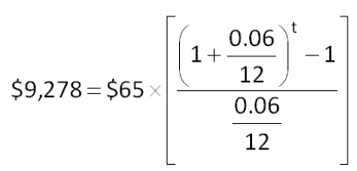
t = ln 1.7137/ln 1.005; t = 108 payments

AACSB: Analytic
Bloom's: Application
Difficulty: Intermediate
EOC #: 6-40
Learning Objective: 6-2
Section: 6.2
Topic: Number of payments
122. You want to borrow $47,170 from your local bank to buy a new sailboat. You can afford to make monthly payments of $1,160, but no more. Assume monthly compounding. What is the highest rate you can afford on a 48-month APR loan?
A. 8.38 percent
B. 8.67 percent
C. 8.82 percent
D. 9.01 percent
E. 9.18 percent
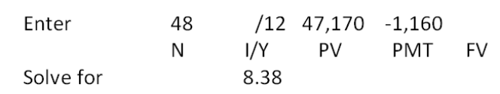

AACSB: Analytic
Bloom's: Application
Difficulty: Intermediate
EOC #: 6-41
Learning Objective: 6-2
Section: 6.2
Topic: Interest rate
123. You need a 25-year, fixed-rate mortgage to buy a new home for $240,000. Your mortgage bank will lend you the money at a 7.5 percent APR for this 300-month loan, with interest compounded monthly. However, you can only afford monthly payments of $850, so you offer to pay off any remaining loan balance at the end of the loan in the form of a single balloon payment. What will be the amount of the balloon payment if you are to keep your monthly payments at $850?
A. $738,464
B. $745,316
C. $767,480
D. $810,220
E. $847,315
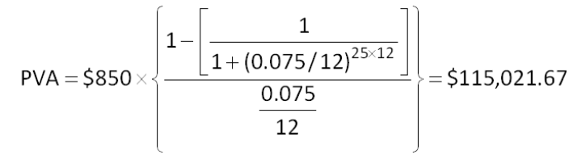
Remaining principal = $240,000 - $115,021.67 = $124,978.33
Balloon payment = $124,978.33  [1 + (0.075/12)]²⁵ ^{ 12} = $810,220

AACSB: Analytic
Bloom's: Analysis
Difficulty: Intermediate
EOC #: 6-42
Learning Objective: 6-2
Section: 6.2
Topic: Loan payment
124. The present value of the following cash flow stream is $5,933.86 when discounted at 11 percent annually. What is the value of the missing cash flow?
A. $1,500
B. $1,750
C. $2,000
D. $2,250
E. $2,500
PV of missing cash flow = $5,933.86 - ($2,000/1.11) - ($1,750/1.11³) - ($1,250/1.11⁴) = $2,029.06
CF₂ = $2,029.06  1.11² = $2,500

AACSB: Analytic
Bloom's: Application
Difficulty: Intermediate
EOC #: 6-43
Learning Objective: 6-1
Section: 6.1
Topic: Present and future values
125. You have just purchased a new warehouse. To finance the purchase, you've arranged for a 30-year mortgage loan for 80 percent of the $2,600,000 purchase price. The monthly payment on this loan will be $11,000. What is the effective annual rate on this loan?
A. 4.98 percent
B. 5.25 percent
C. 5.46 percent
D. 6.01 percent
E. 6.50 percent
Loan amount = $2,600,000  0.80 = $2,080,000
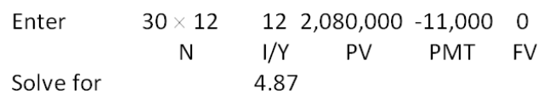
EAR = [1 + (.0487/12)]¹² - 1 = 4.98 percent

AACSB: Analytic
Bloom's: Analysis
Difficulty: Intermediate
EOC #: 6-45
Learning Objective: 6-4
Section: 6.3
Topic: Effective annual rate
126. Consider a firm with a contract to sell an asset 3 years from now for $90,000. The asset costs $71,000 to produce today. At what rate will the firm just break even on this contract?
A. 7.87 percent
B. 8.01 percent
C. 8.23 percent
D. 8.57 percent
E. 8.90 percent
$90,000 = $71,000  (1 + r)³; r = 8.23 percent

AACSB: Analytic
Bloom's: Analysis
Difficulty: Intermediate
EOC #: 6-46
Learning Objective: 6-2
Section: 6.2
Topic: Break-even interest
127. What is the present value of $1,100 per year, at a discount rate of 10 percent if the first payment is received 6 years from now and the last payment is received 28 years from now?
A. $6,067.36
B. $6,138.87
C. $6,333.33
D. $6,420.12
E. $6,511.08
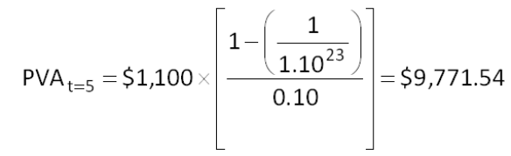
PV = $9,771.54/1.1⁵ = $6,067.36

AACSB: Analytic
Bloom's: Application
Difficulty: Intermediate
EOC #: 6-47
Learning Objective: 6-1
Section: 6.2
Topic: Present value
128. You have your choice of two investment accounts. Investment A is a 5-year annuity that features end-of-month $2,500 payments and has an interest rate of 11.5 percent compounded monthly. Investment B is a 10.5 percent continuously compounded lump sum investment, also good for five years. How much would you need to invest in B today for it to be worth as much as investment A five years from now?
A. $108,206.67
B. $119,176.06
C. $124,318.08
D. $129,407.17
E. $131,008.15
FVA = $2,500  [{[1 + (0.115/12)]⁵ ^{ 12} -1}/(0.115/12)] = $201,462.23
PV = $201,462.23 e⁻¹ ^{ 0.105} ^{5} = $119,176.06

AACSB: Analytic
Bloom's: Application
Difficulty: Intermediate
EOC #: 6-49
Learning Objective: 6-1
Section: 6.3
Topic: Present value
129. Given an interest rate of 8 percent per year, what is the value at date t = 9 of a perpetual stream of $500 annual payments that begins at date t = 17?
A. $3,646.81
B. $4,109.19
C. $4,307.78
D. $6,250.00
E. $6,487.17
PV_{t = 16} = $500/.08 = $6,250
PV_{t = 9} = $6,250/1.08¹⁶⁻⁹ = $3,646.81

AACSB: Analytic
Bloom's: Application
Difficulty: Intermediate
EOC #: 6-50
Learning Objective: 6-1
Section: 6.2
Topic: Perpetuity present value
130. You want to buy a new sports car for $55,000. The contract is in the form of a 60-month annuity due at a 6 percent APR, compounded monthly. What will your monthly payment be?
A. $1,047.90
B. $1,053.87
C. $1,058.01
D. $1,063.30
E. $1,072.11
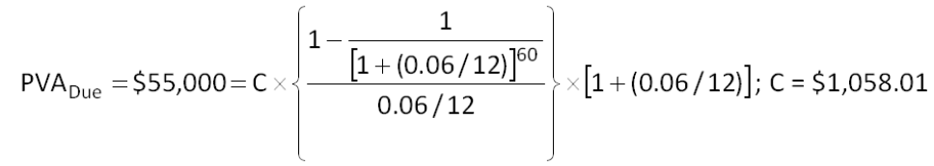

AACSB: Analytic
Bloom's: Application
Difficulty: Intermediate
EOC #: 6-54
Learning Objective: 6-2
Section: 6.2
Topic: Annuity due
131. You are looking at a one-year loan of $10,000. The interest rate is quoted as 10 percent plus 5 points. A point on a loan is simply 1 percent (one percentage point) of the loan amount. Quotes similar to this one are very common with home mortgages. The interest rate quotation in this example requires the borrower to pay 5 points to the lender up front and repay the loan later with 10 percent interest. What is the actual rate you are paying on this loan?
A. 15.00 percent
B. 15.47 percent
C. 15.55 percent
D. 15.79 percent
E. 15.84 percent
Loan amount received = $10,000  (1 - .05) = $9,500
Loan repayment amount = $10,000  1.10¹ = $11,000
$11,000 = $9,500  (1 + r)¹; r = 15.79 percent

AACSB: Analytic
Bloom's: Synthesis
Difficulty: Challenge
EOC #: 6-62
Learning Objective: 6-4
Section: 6.4
Topic: Effective rate with points
132. Your holiday ski vacation was great, but it unfortunately ran a bit over budget. All is not lost. You just received an offer in the mail to transfer your $5,000 balance from your current credit card, which charges an annual rate of 18.7 percent, to a new credit card charging a rate of 9.4 percent. You plan to make payments of $510 a month on this debt. How many less payments will you have to make to pay off this debt if you transfer the balance to the new card?
A. 0.36 payments
B. 0.48 payments
C. 1.10 payments
D. 1.23 payments
E. 2.49 payments
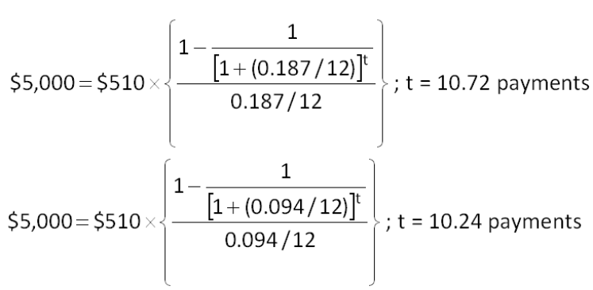
$5,000 = $510  [(1 - {1 + (0.094/12)]}^{t})/(0.094/12)]
t = ln (1/0.9232)/ln 1.007833; t = 10.24 payments
Difference = 10.72 - 10.24 = 0.48 payments

AACSB: Analytic
Bloom's: Analysis
Difficulty: Challenge
EOC #: 6-67
Learning Objective: 6-2
Section: 6.2
Topic: Number of periods

